IQAC 2024

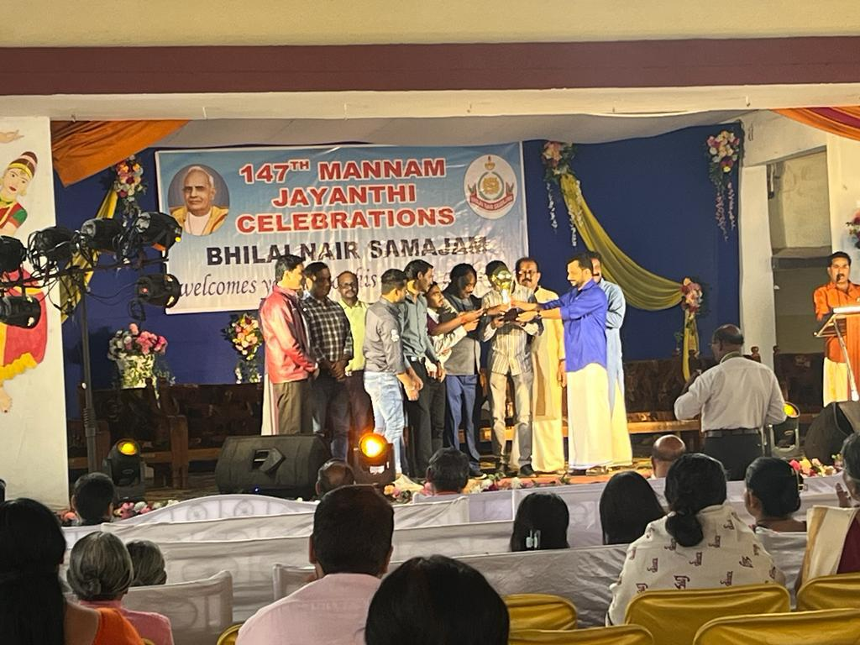
eUue ta;rh

;ksxk 05&02&2024 jaftrk ?kjs 2024
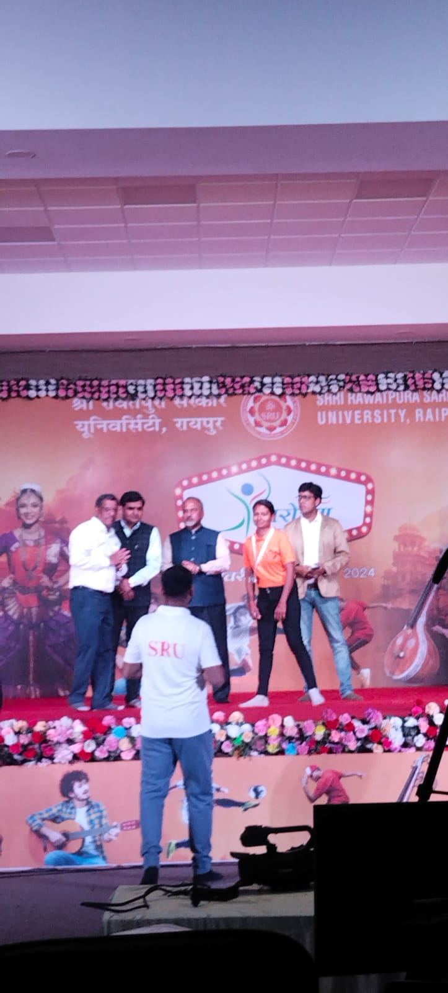
;wiksfj;k 2024
3 Days Event 06&02&2024

;wiksfj;k & Best out of the waste - 1st Day 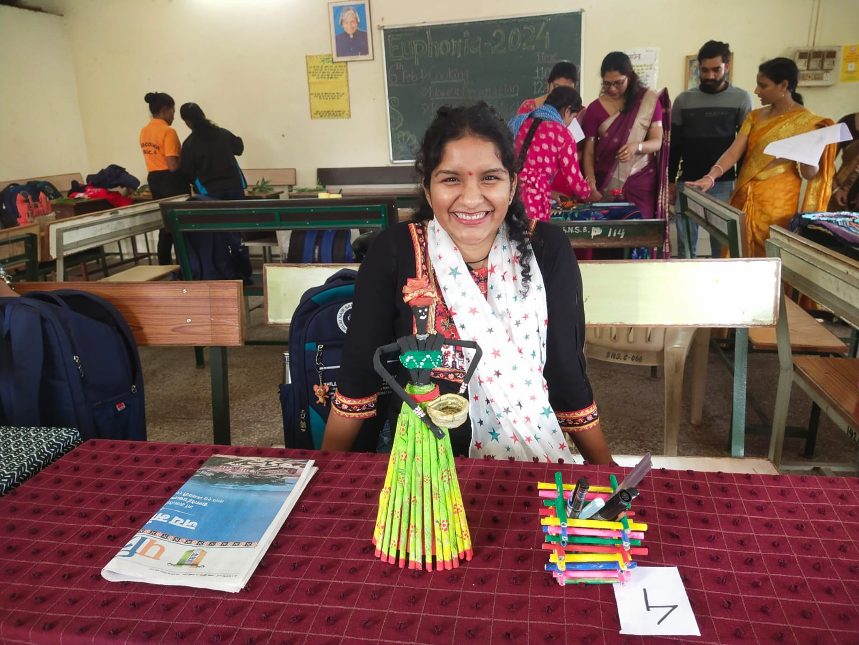

07&02&2024 2nd Day ;wiksfj;k 2024
Hair Style Competition ,
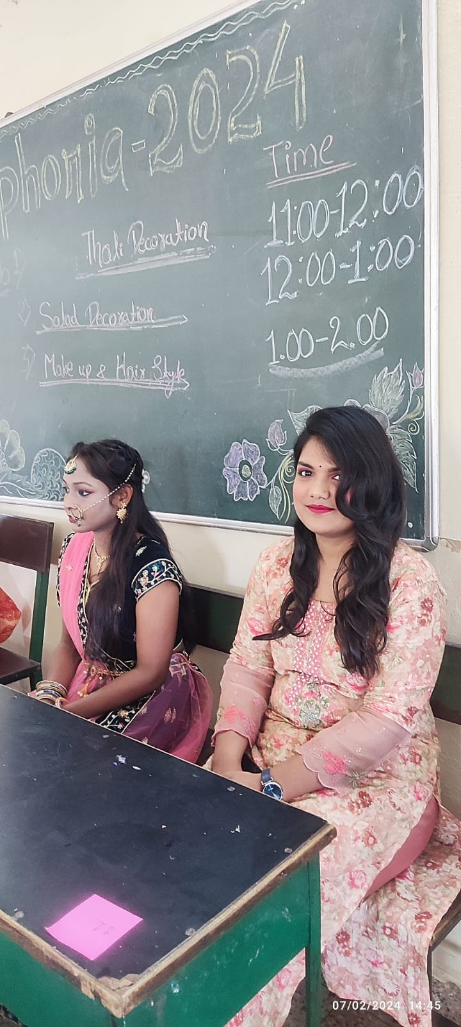

Qwy lTtk izfr;ksfxrk
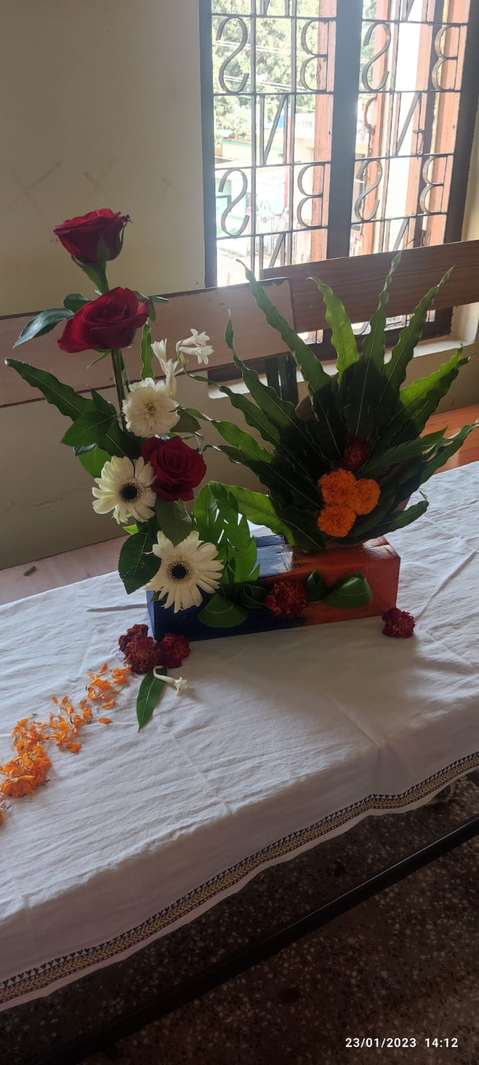

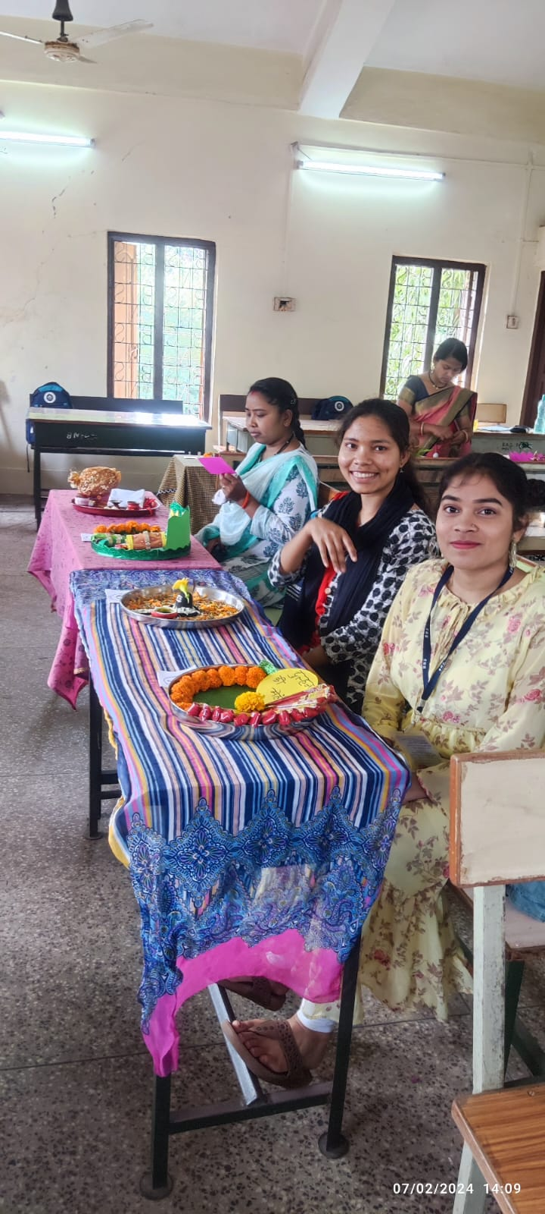
Fkkyh ltkvks

;wiksfj;k 3rd day [ksydwn izfr;ksfxrk & 08&02&2024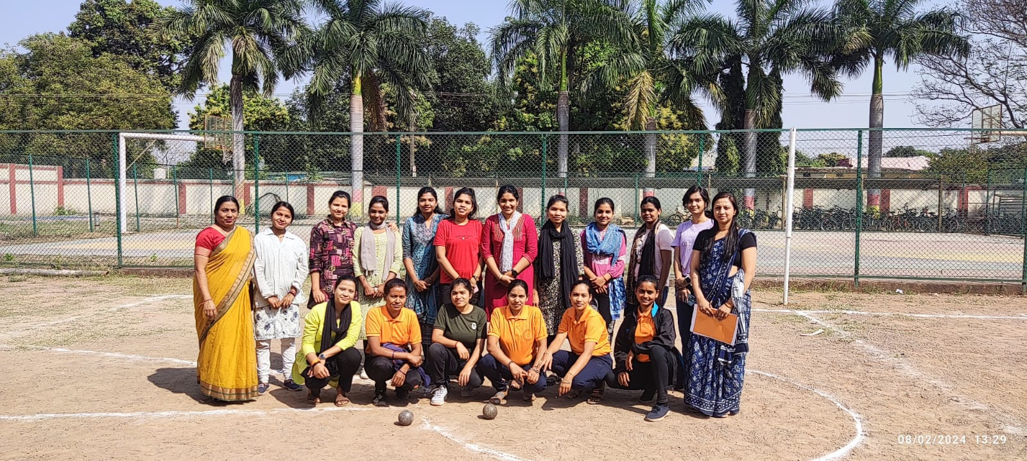

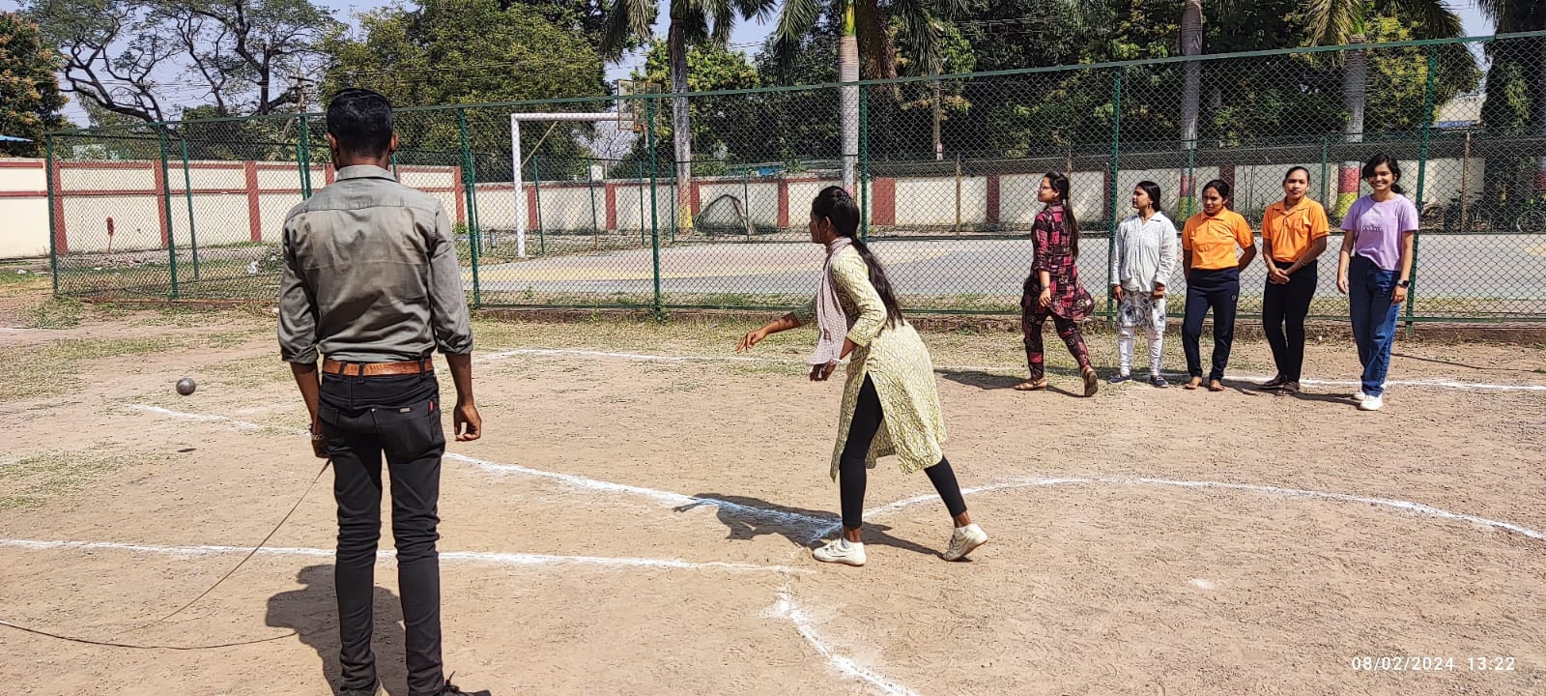
10/2/2024 - Prize Distribution Ceremony 2024
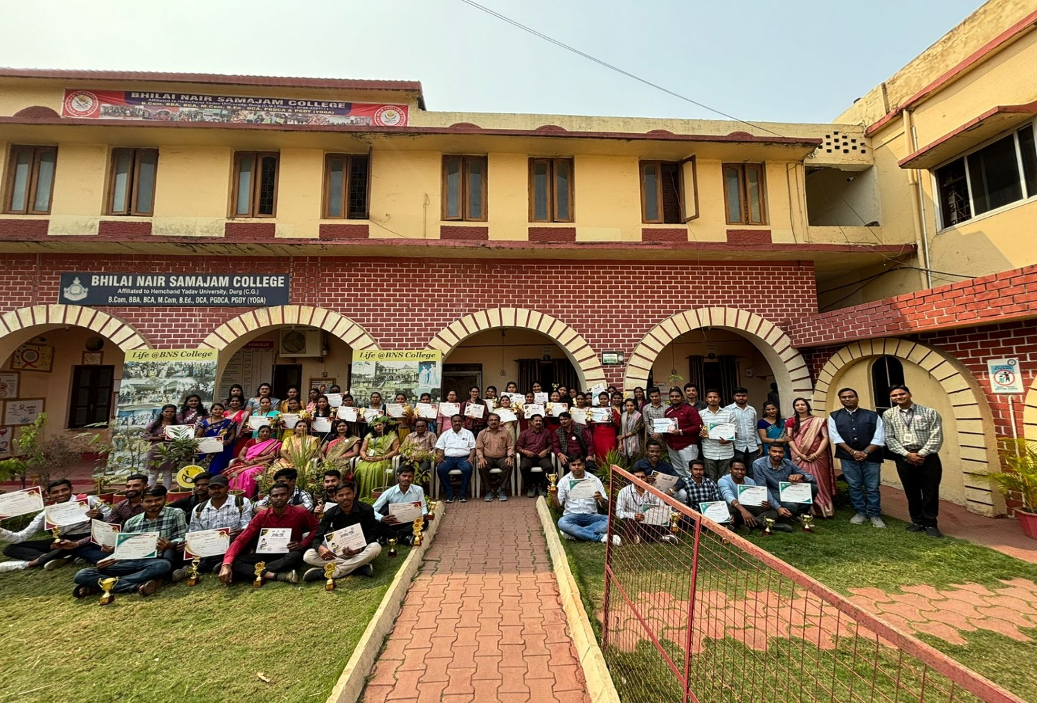
27/02/2024 – ernkrk tkx:drk vfHk;ku
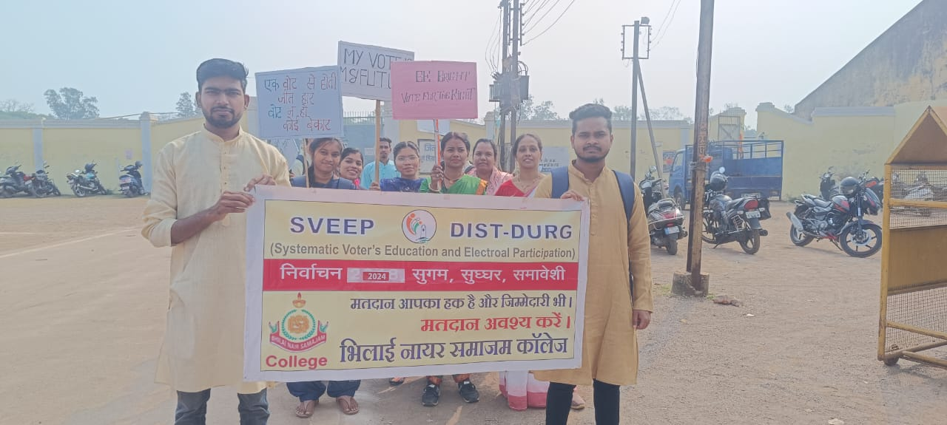
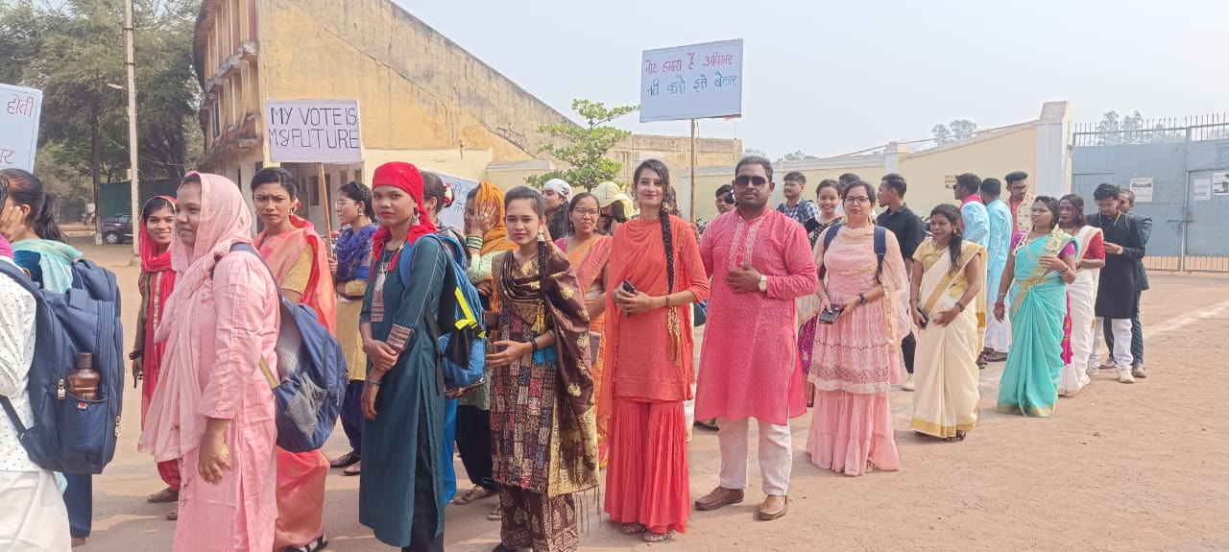
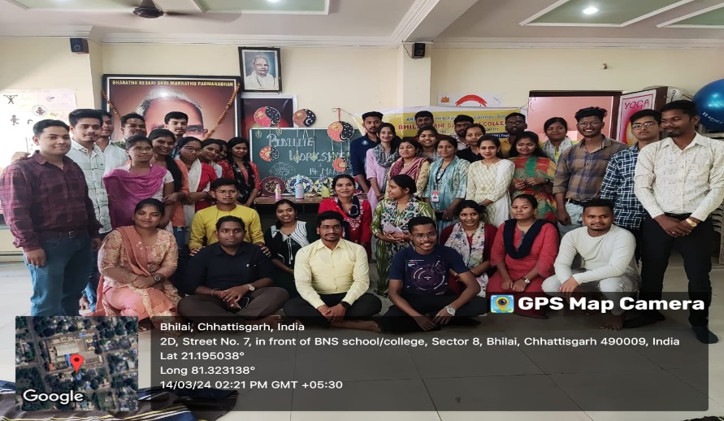
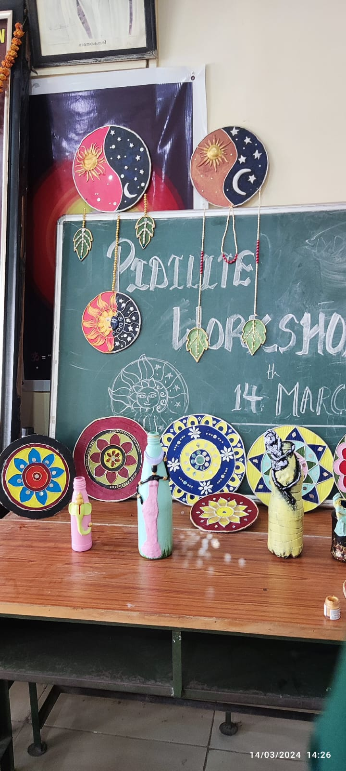
12&03-2024 rhu fnolh; dk;Z”kkyk
PIDILITE -workshop Art & Craft 2024
02&04&2024 &ernkrk tkx:drk 2024
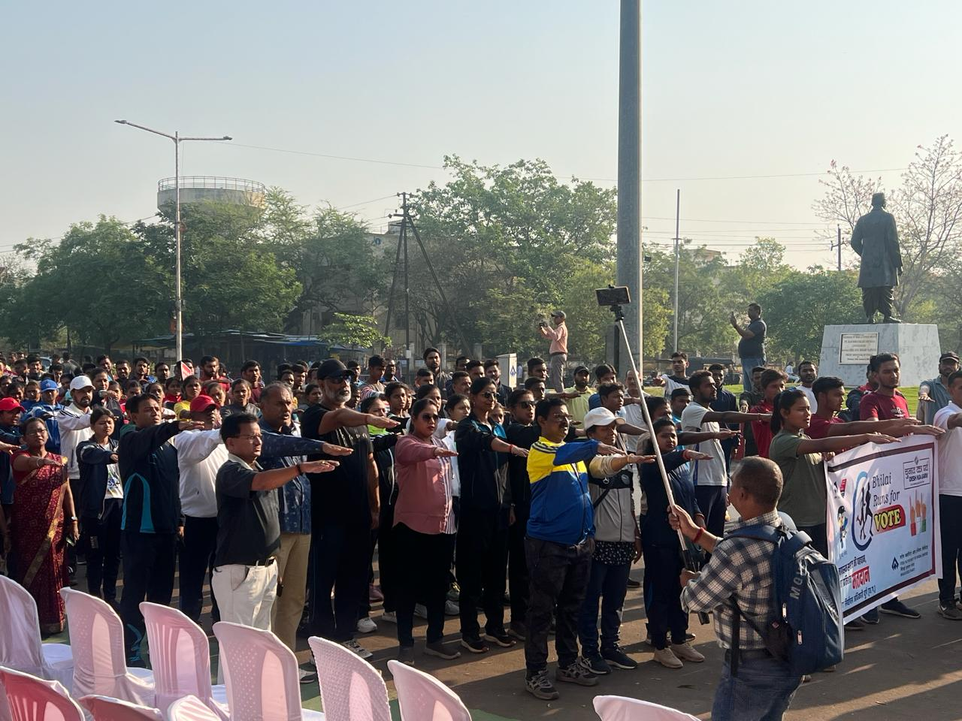
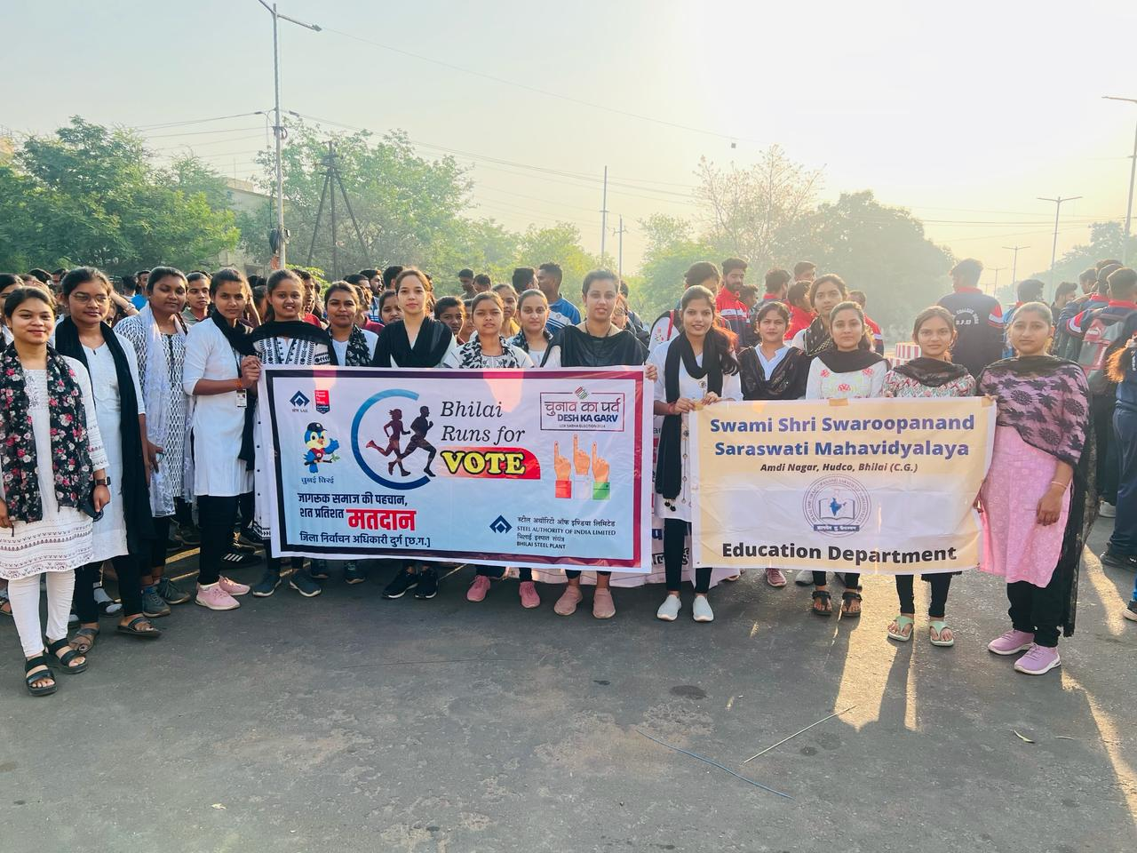

Republic Day 26/01/2024
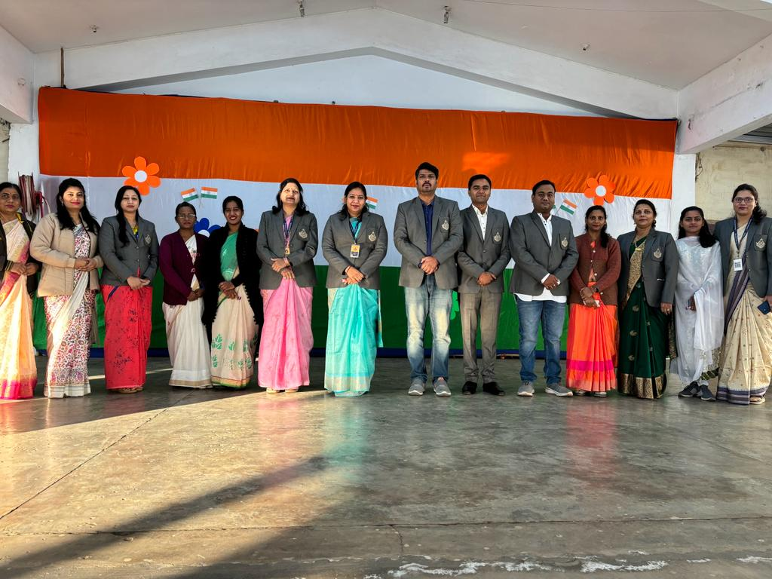

Village Camp -17/01/2024 - Govt ’kkldh; iwoZ ek/;fed fo|ky; Kahamhariya (B.Ed I Sem 23-25 )

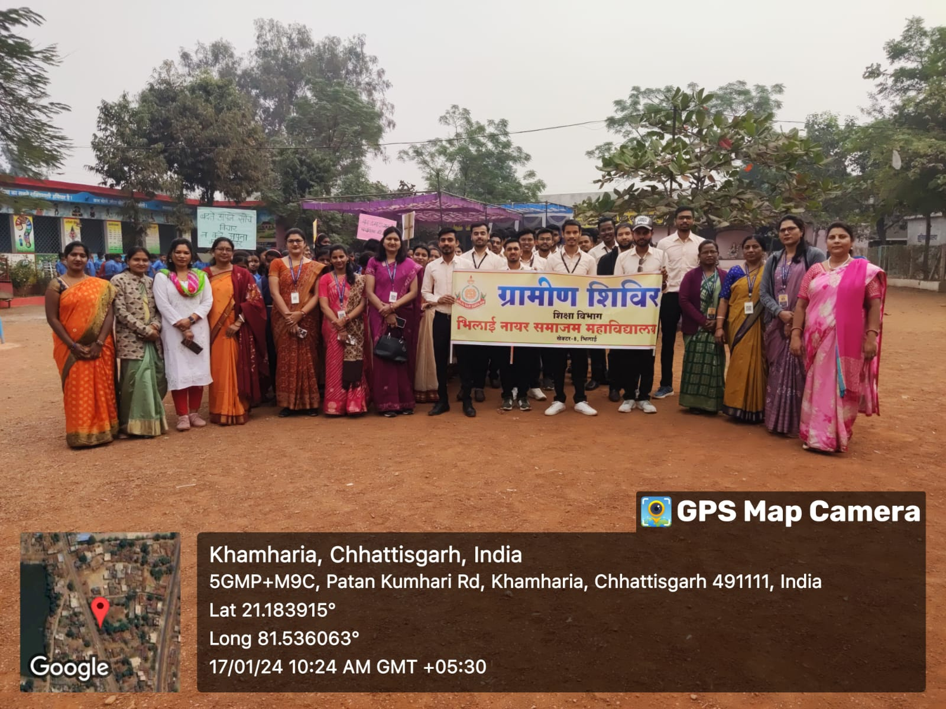

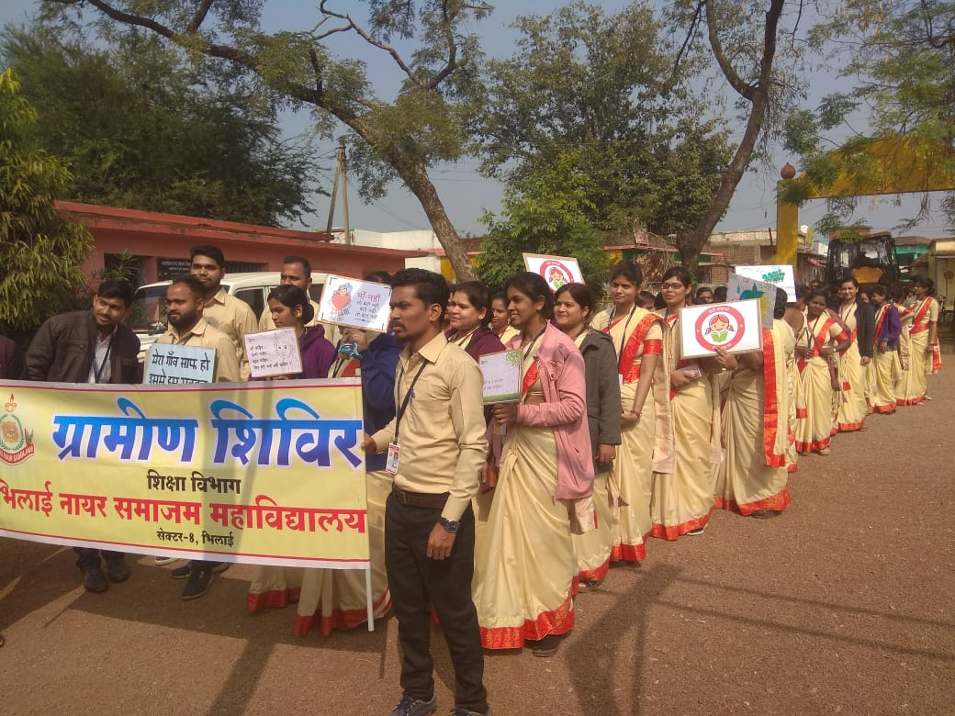
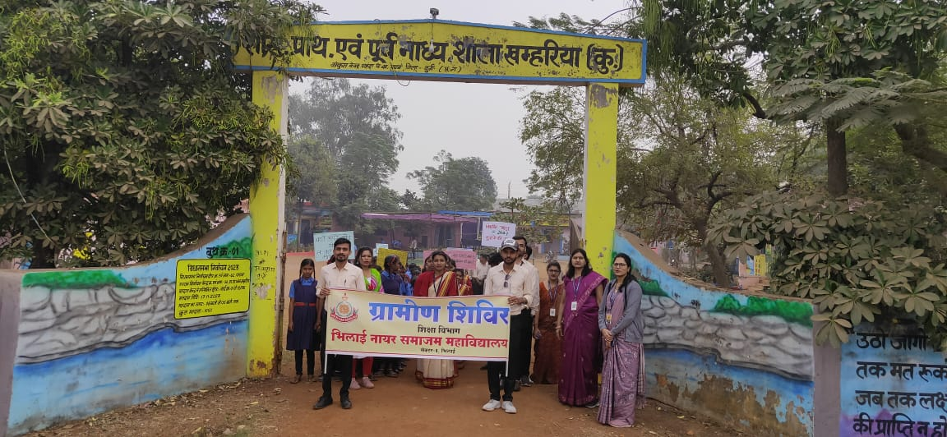

Mannam Jayanti 02/01/2024

IQAC 2023

National Mathematics’ Day - Sai College ,Sector -6
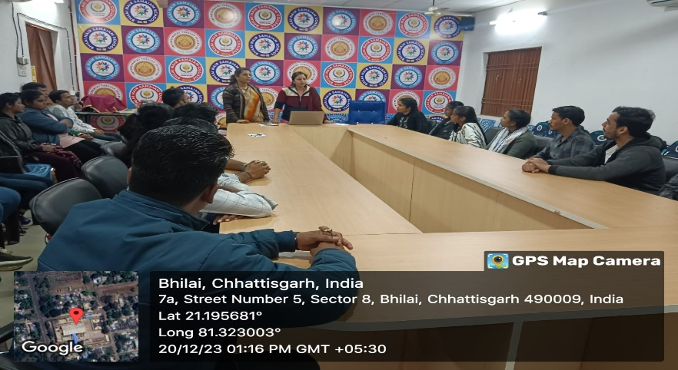
Date :-21 & 22 jan -2023

Visit to Akshaya Patra – Sector – 6 Bhilai-
Date : 16 December 2023

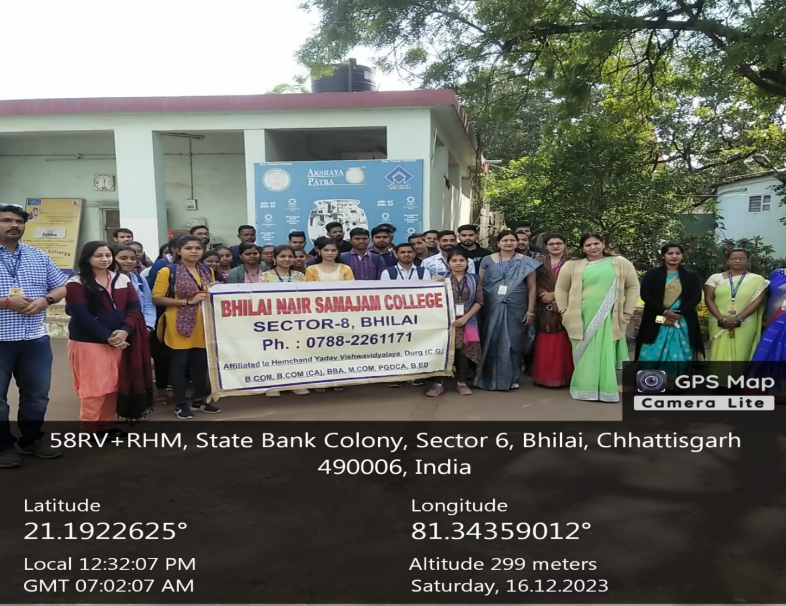

World Aids Day 01/12/2023
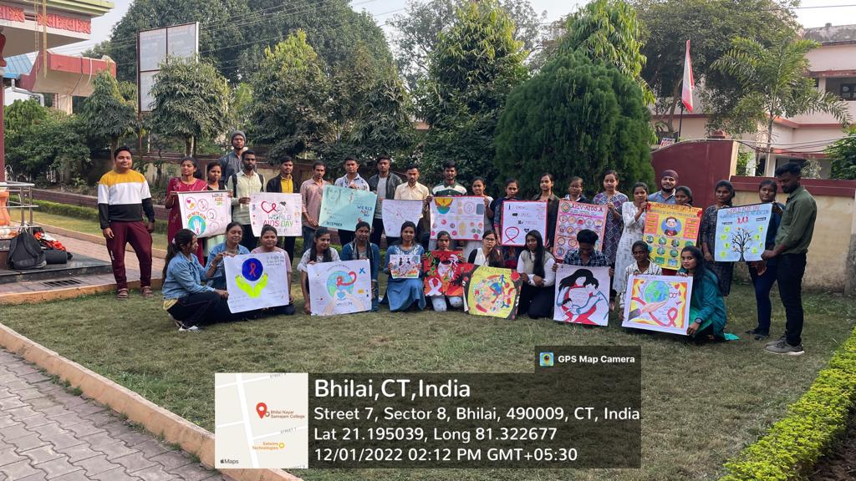

Motivational Workshop - Date-30/11/23
Topic EVOLVE FEARLESSLY :- By Speaker Mr. UDAY MENNON :-

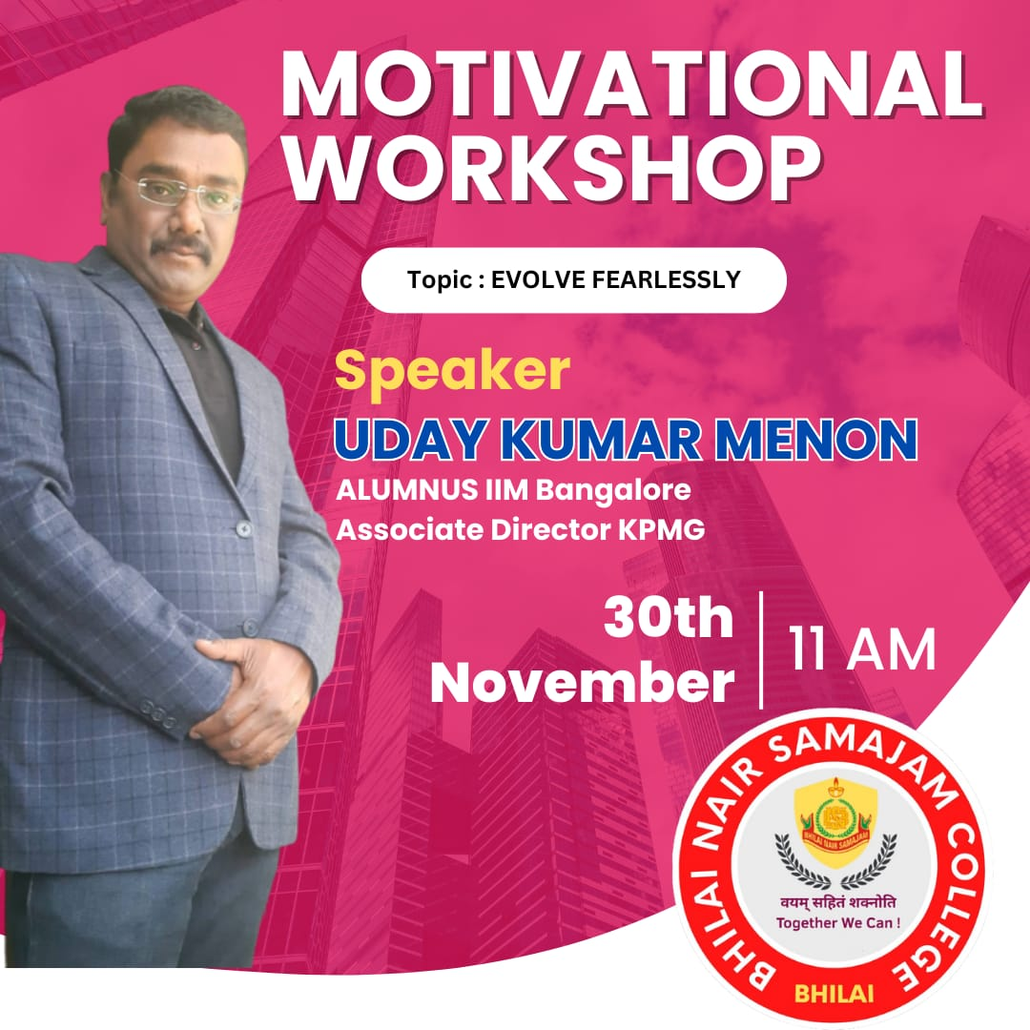

Diwali Anand Mela 07/11/2023

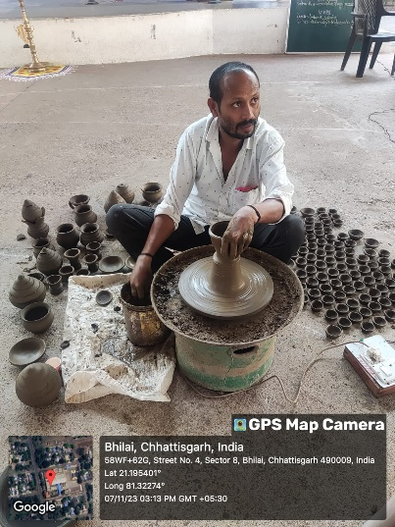
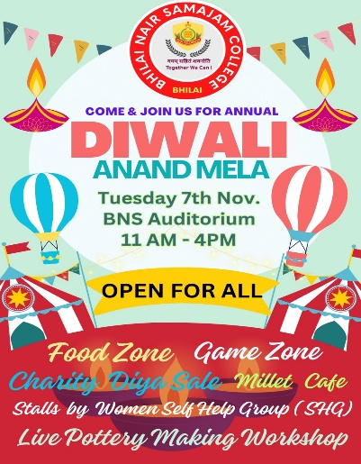

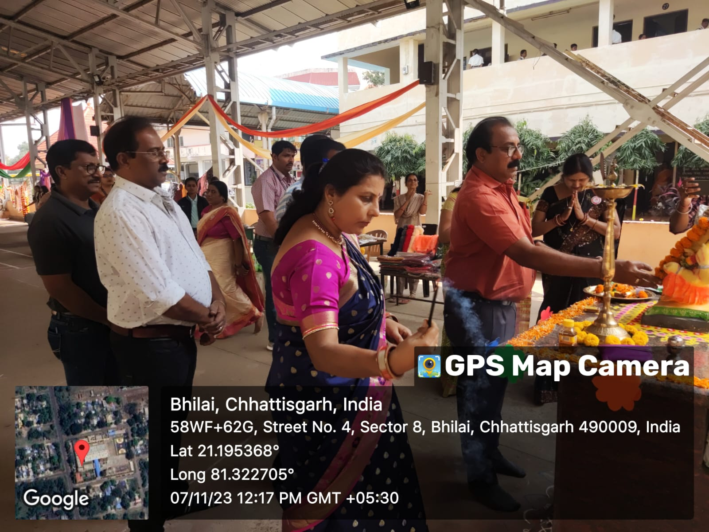
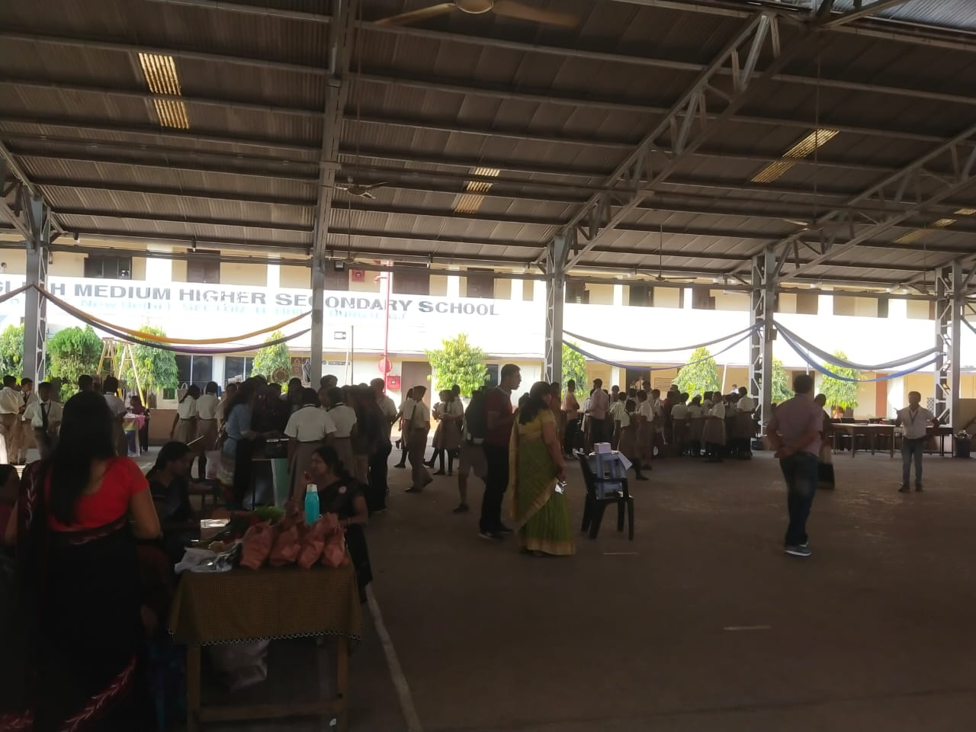
Cultureal fest Sveep dsjy ds ikjaifjd u`R; fr:oknjk dk;Zdze 05/11/2023 cMsrfj;k ifjlj dqEgkjh fHkykbZA
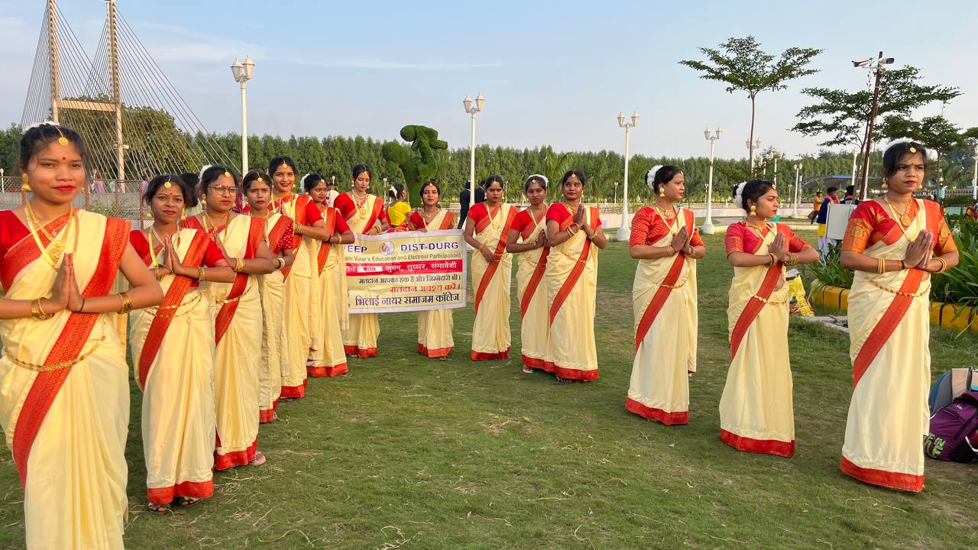
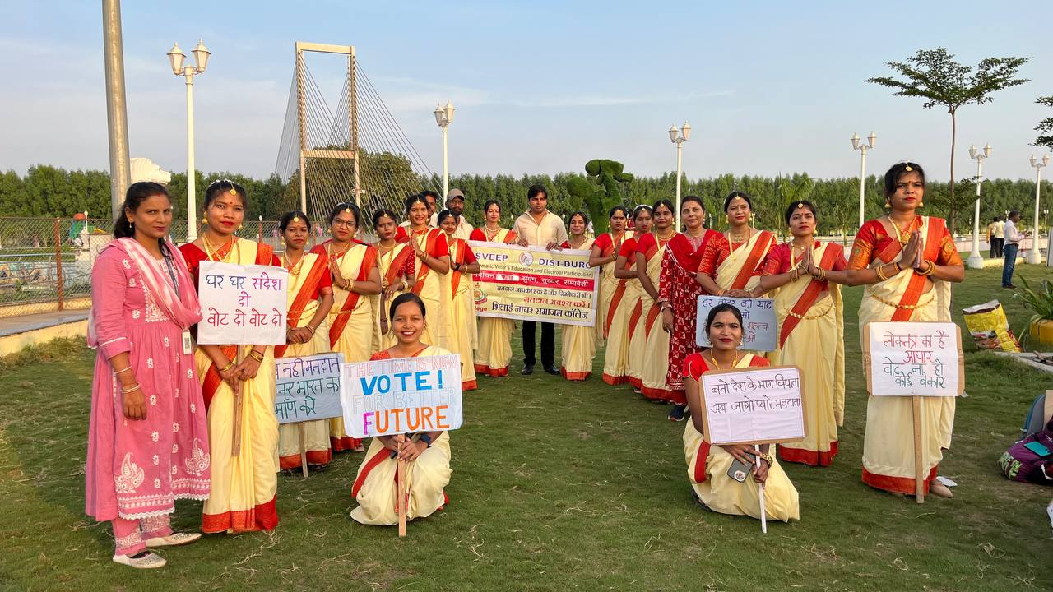

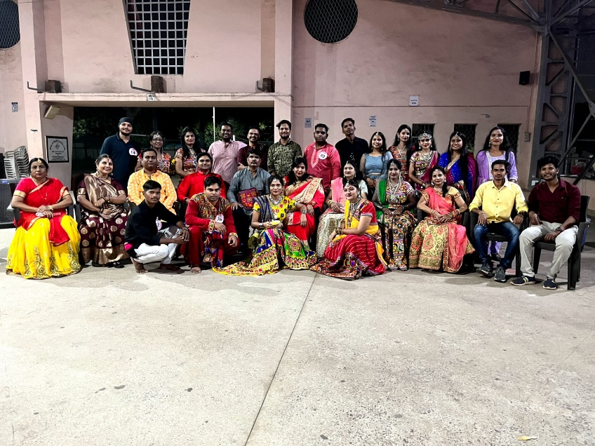
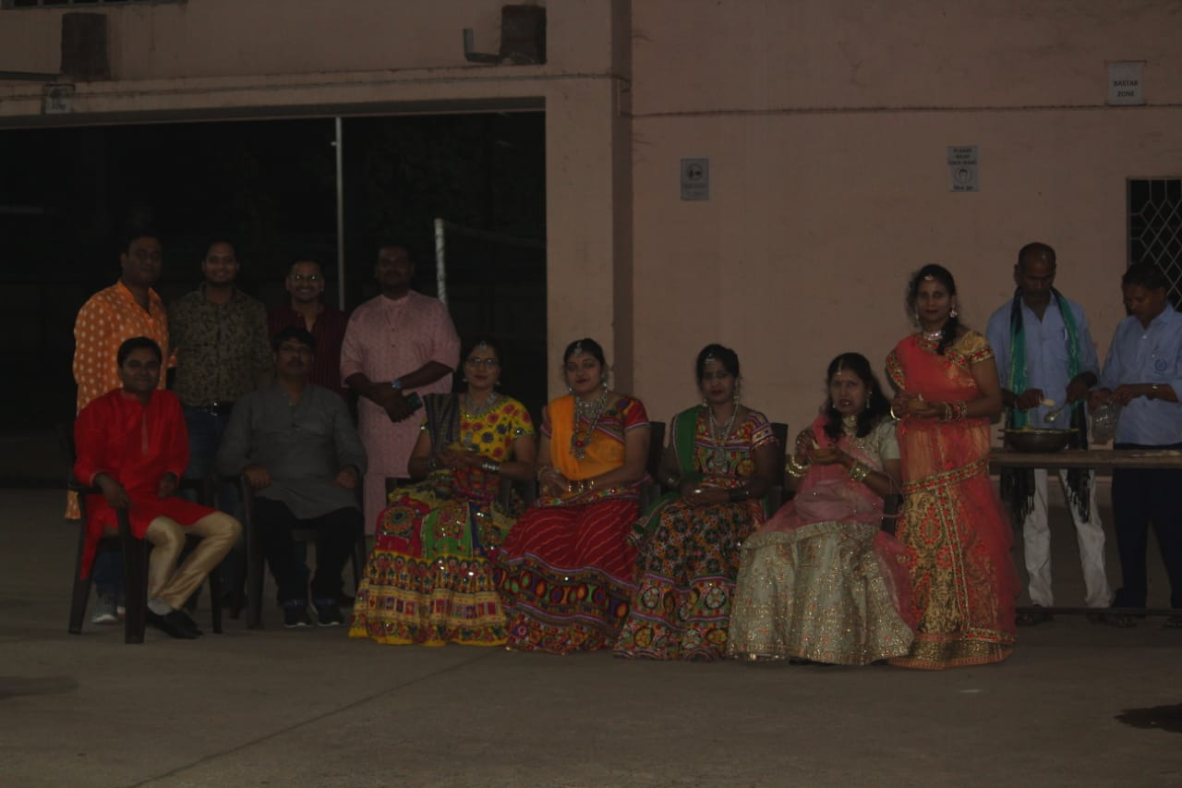
20/10/2023 xjck UkkbZV

Mkssaxjx< in;kf=;ksa ds fy, LoYikgkj dk forj.k
Date : 18&10&2023
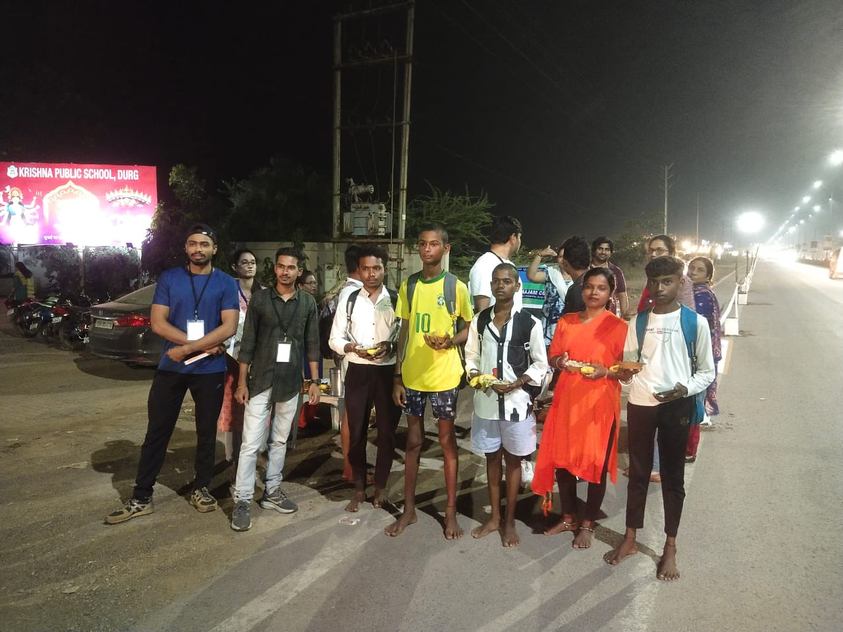
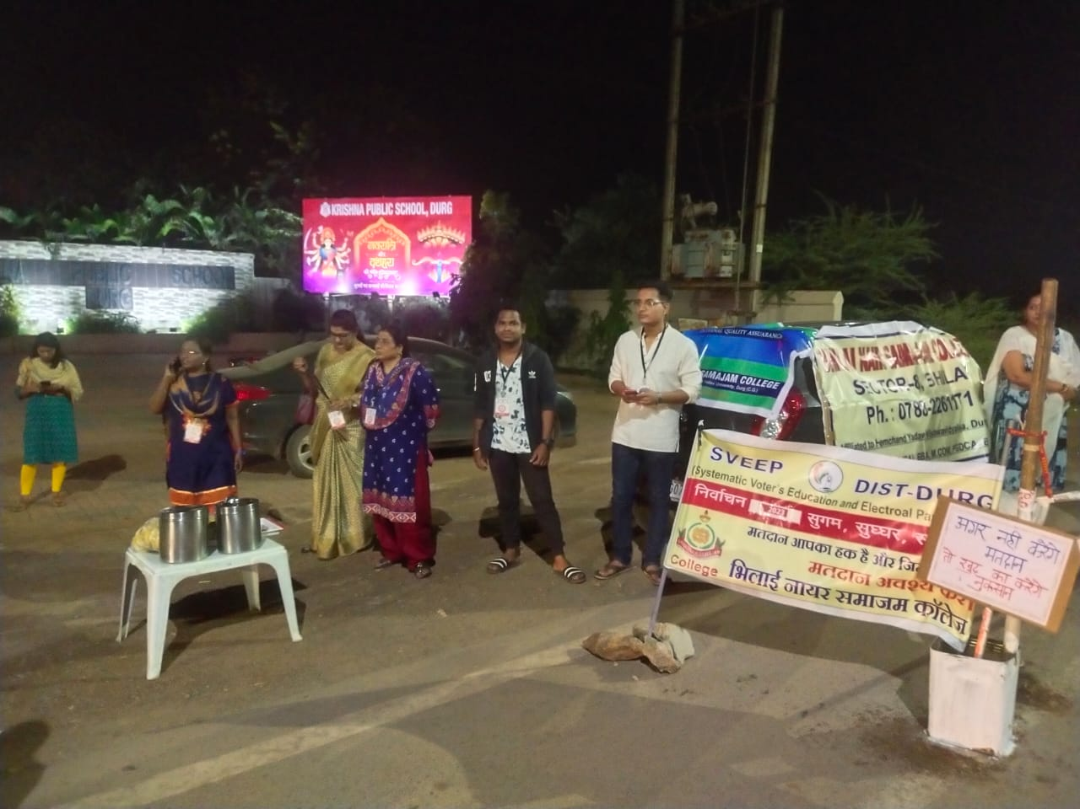

xk/kh t;arh A LoPN Hkkjr vkfHk;ku 1 vDVwcj 2023 LoPN Hkkjr vkfHk;ku & 1 rkjh[k 1 ?kaVk 7 & LoPNrk vkfHk;ku
;wFk jsM dzkWl foax A
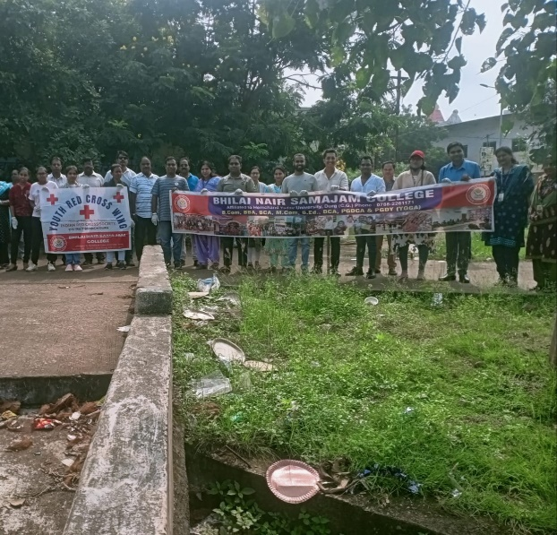
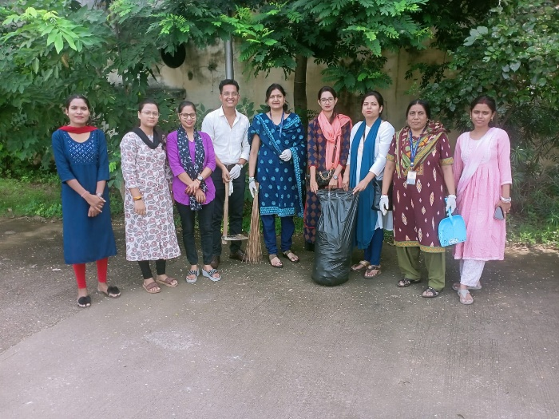
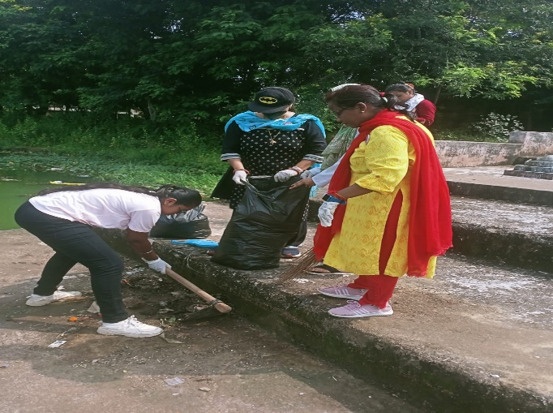
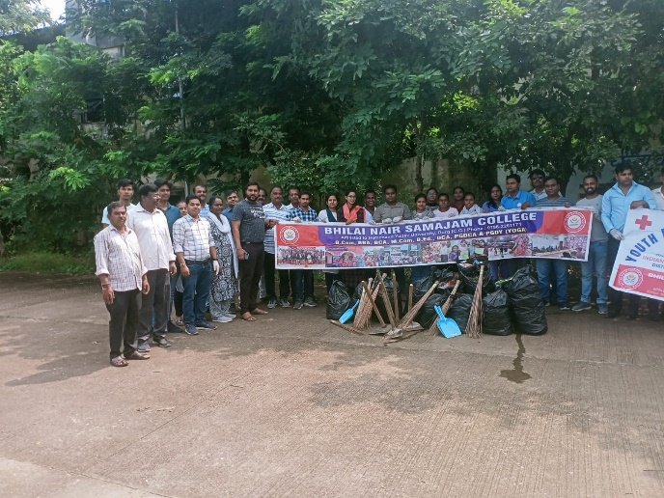

SWEEP Program &esgnha izfr;ksfxrk & 23&09&2023

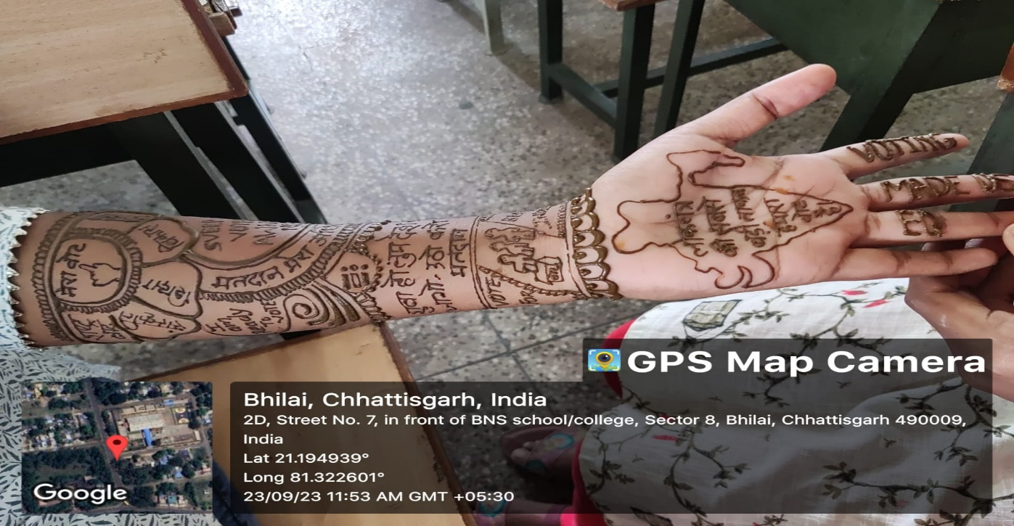

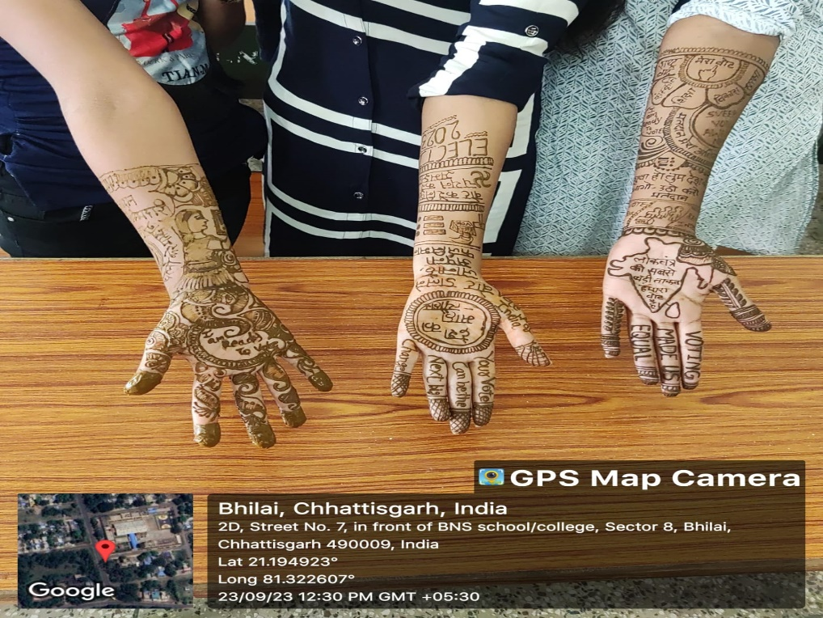

Millets – A Miracle Intercollege Competition
02/09/2023
List – a) Rangoli b) dish Of Millets c) fopkj vfHkO;fDr

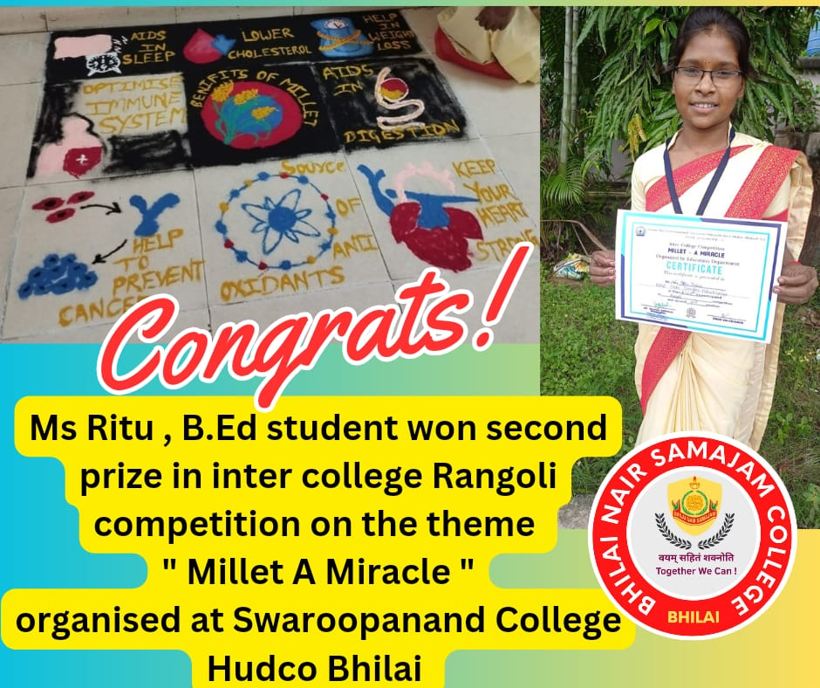

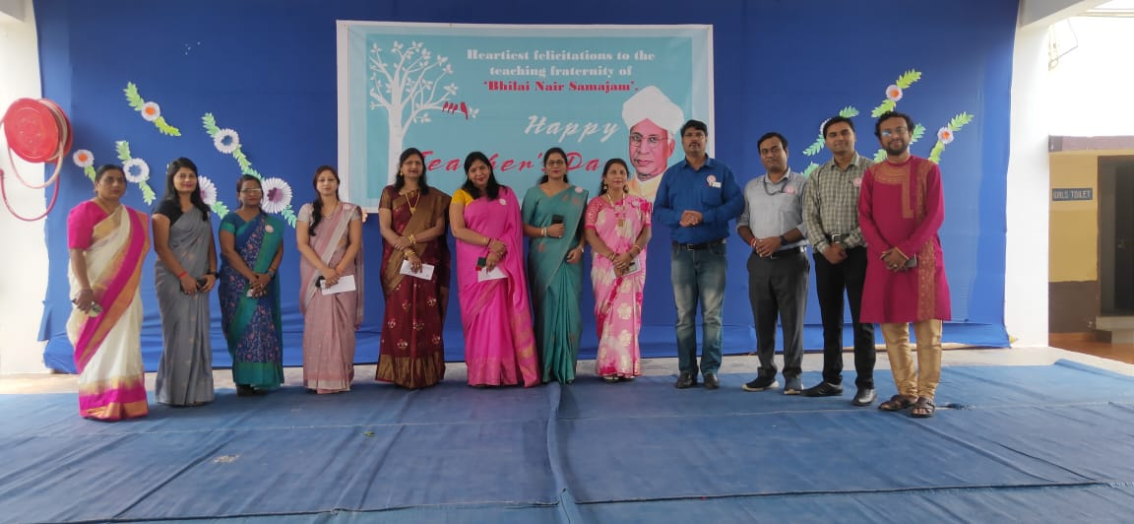
f'k{kd fnol dk;Zdze & 05&09&2023

vrIiw izfr;ksfxrk & dsjy dk ikajifjd Qwyksa dh jaxksyh 26&08&2023
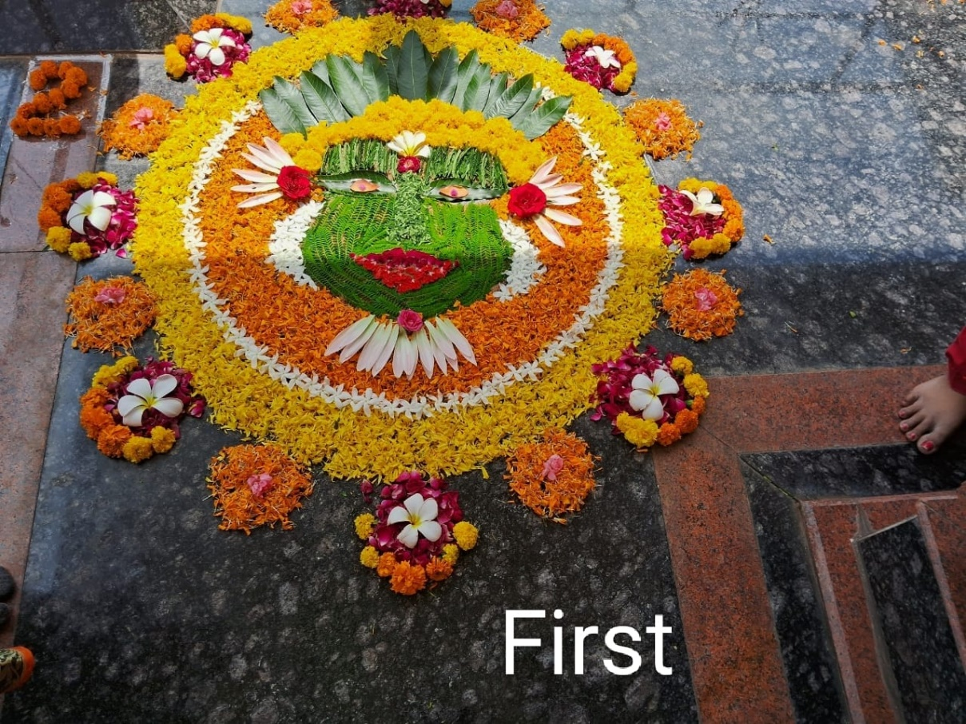

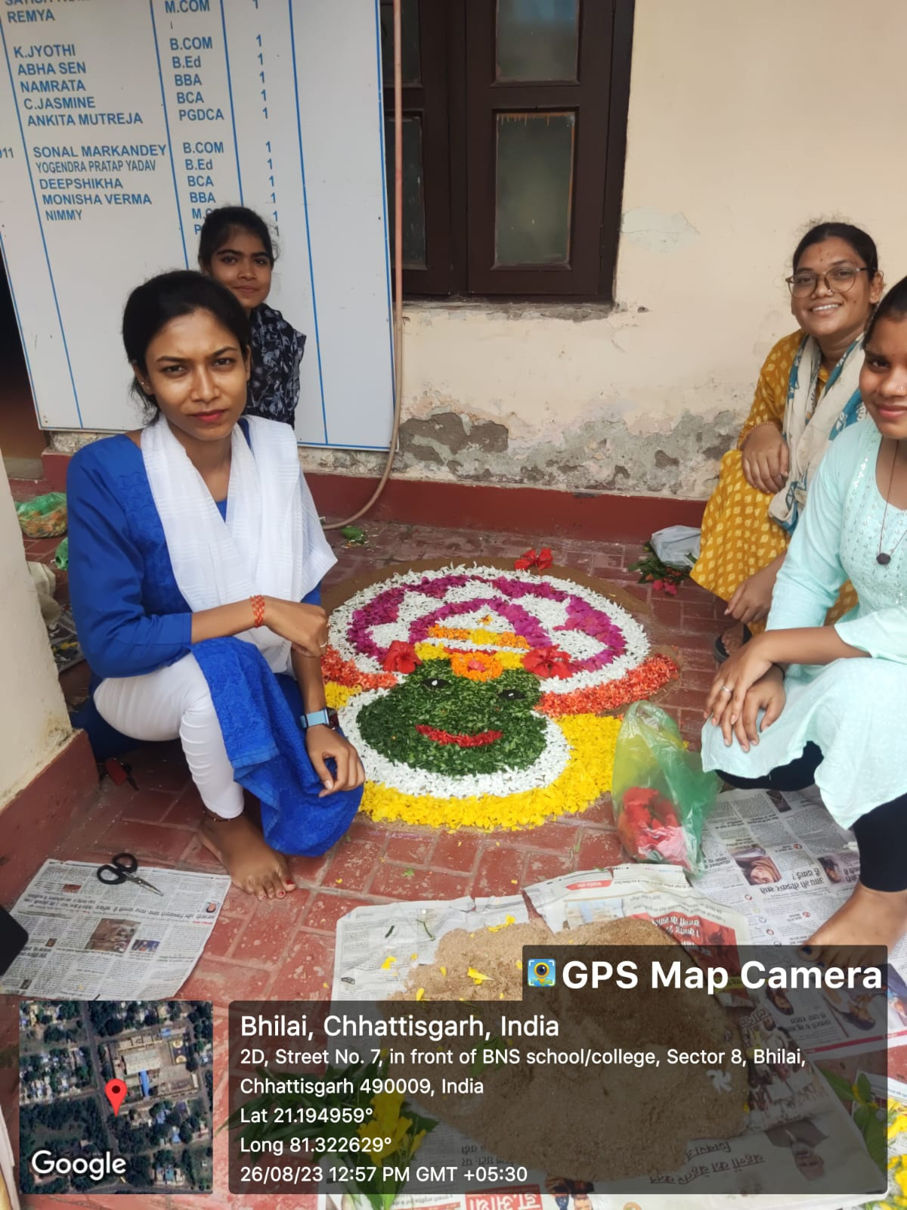

Lorar=k fnol 15&08&2023

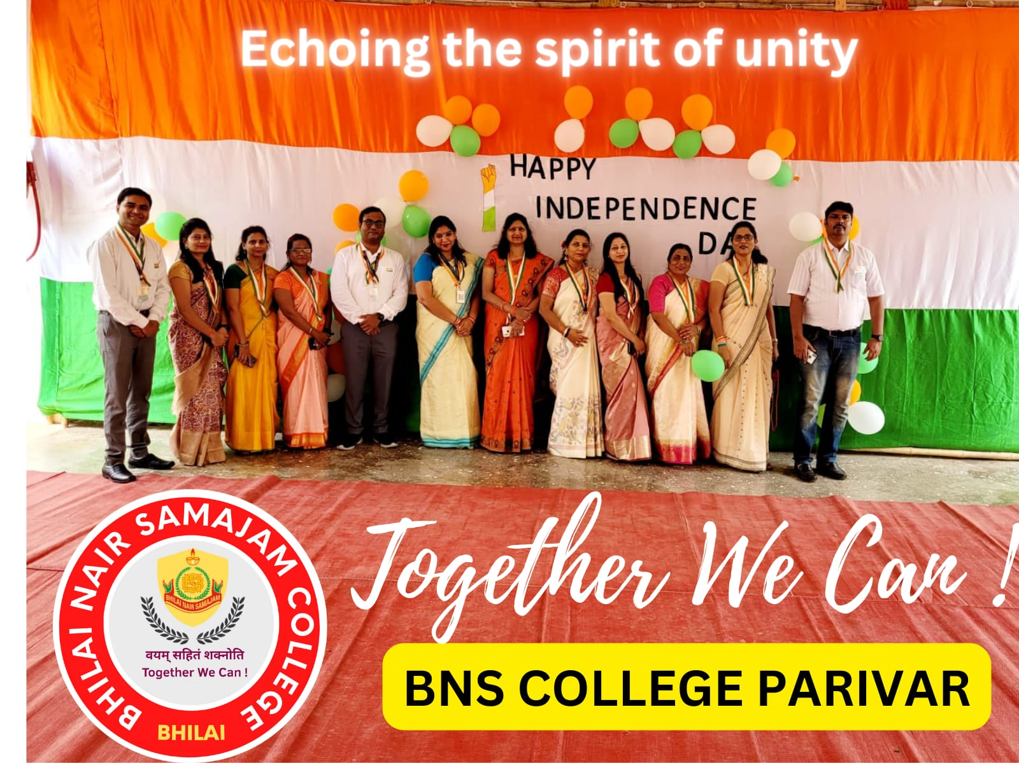

frjaxk jSyh 14&08&2023

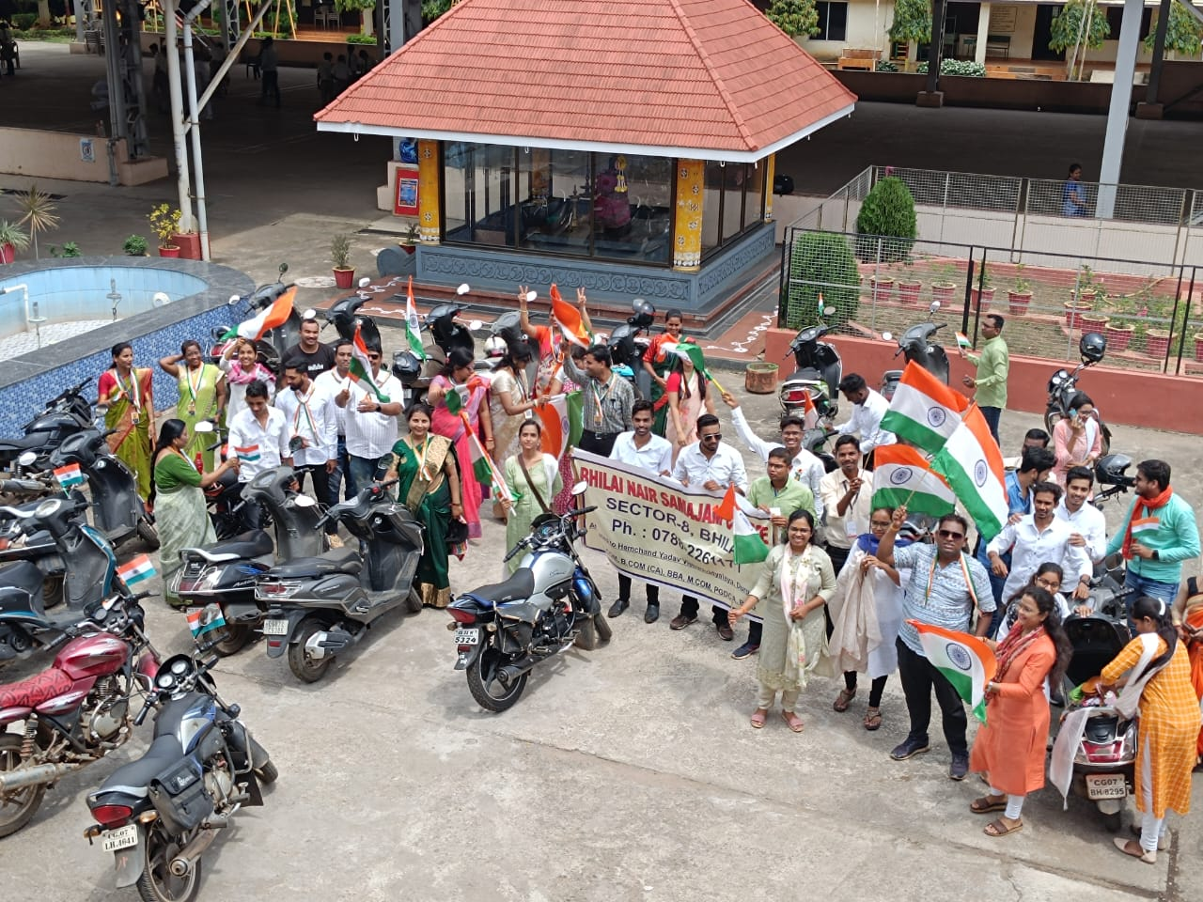

esjs fo|kkFkhZ esjs liuksa dk NÙkhlx< &04&08&2023
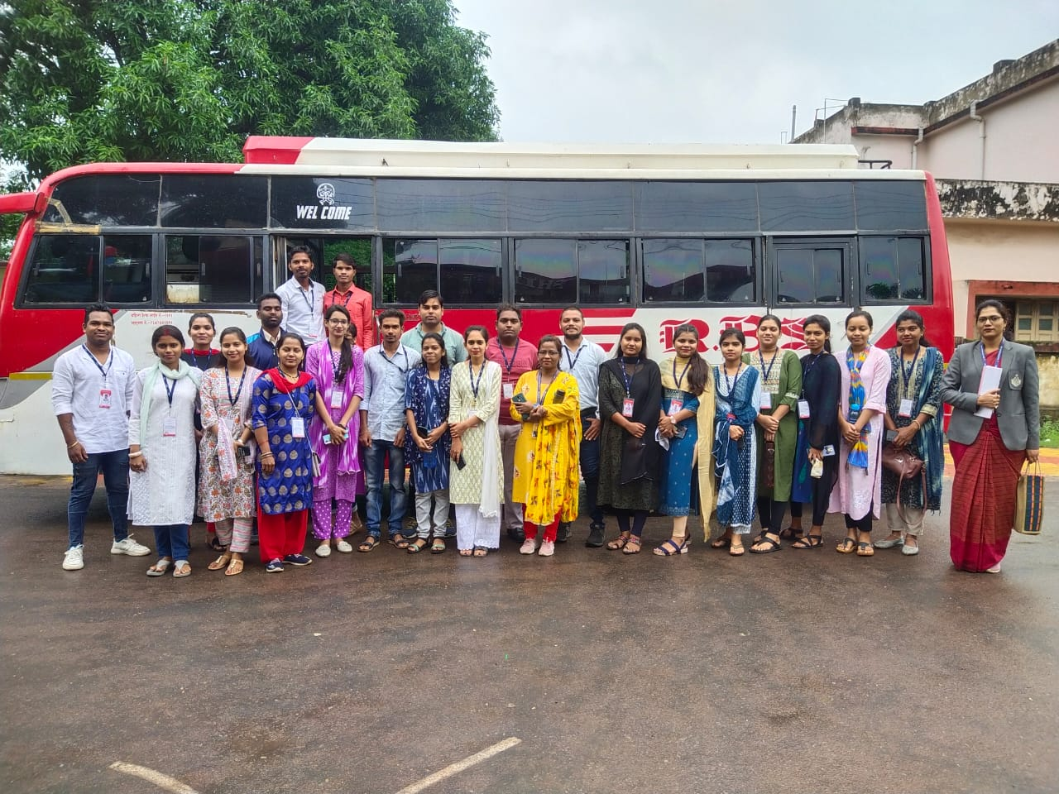
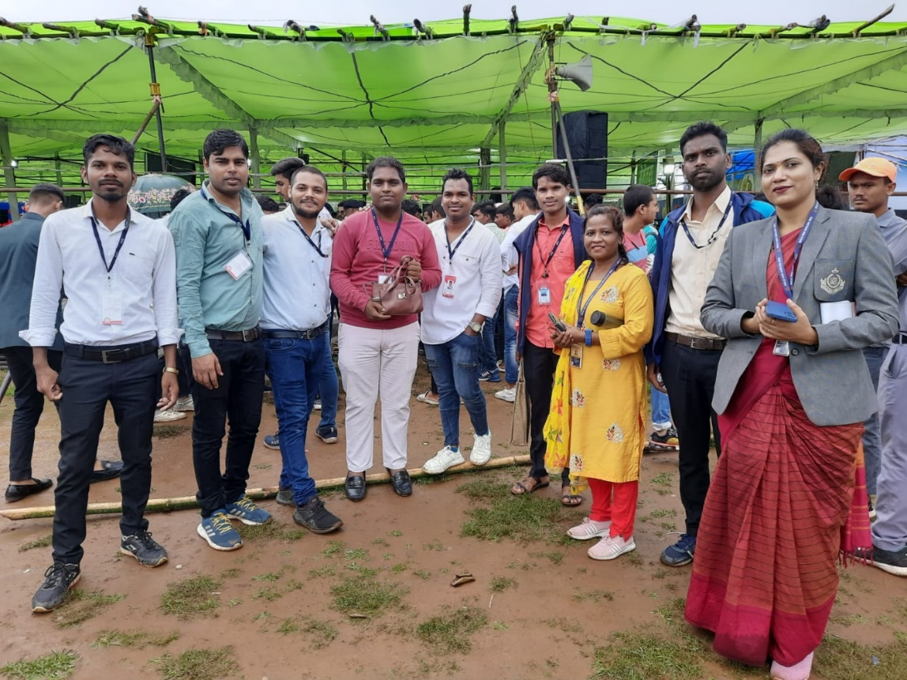

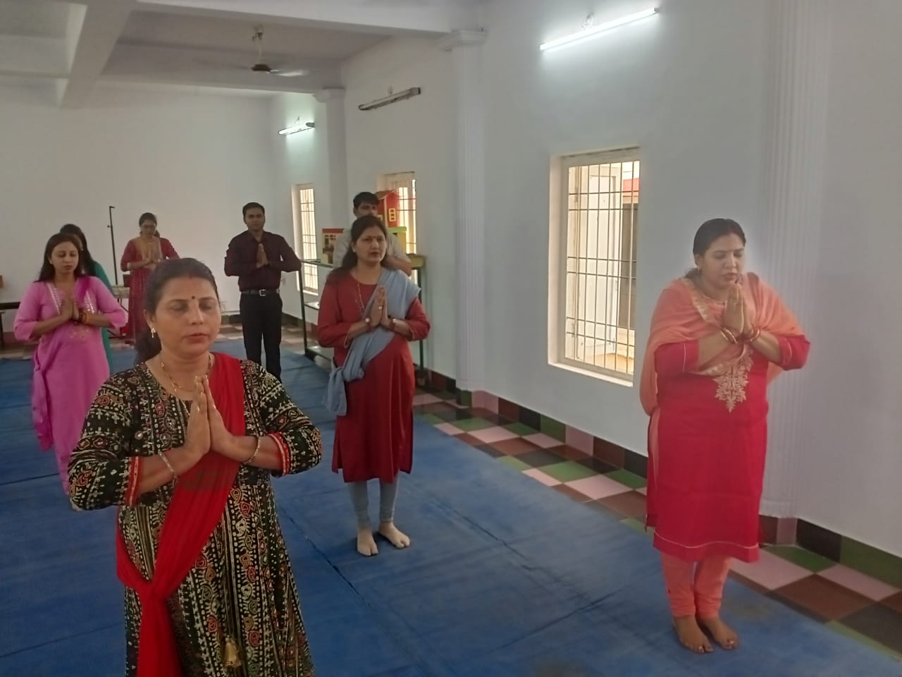

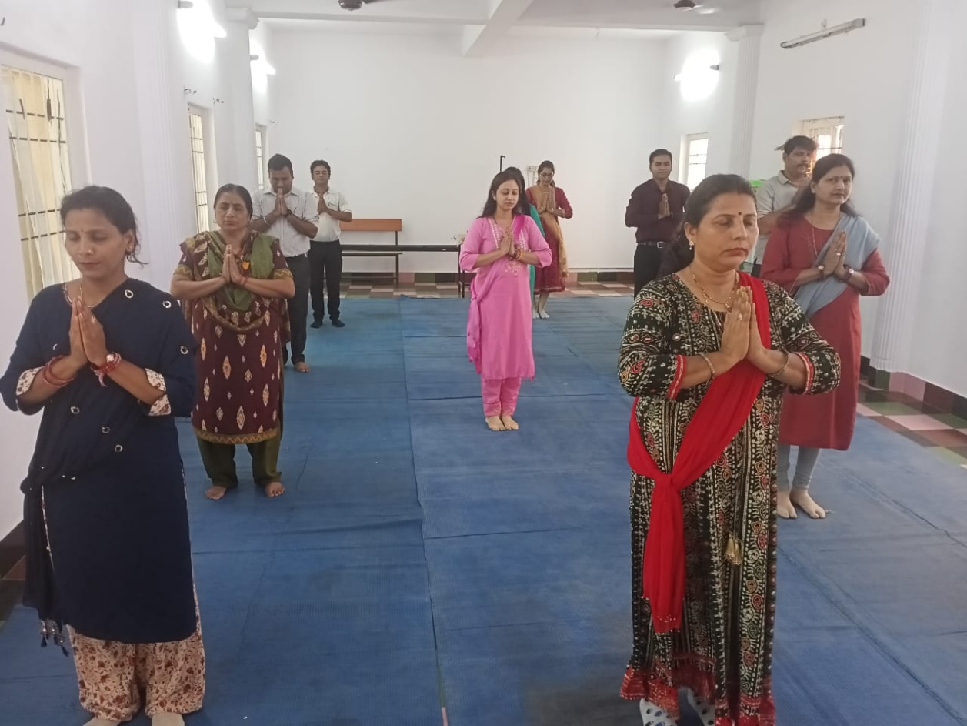

World Red Cross Day - 08&05&2023
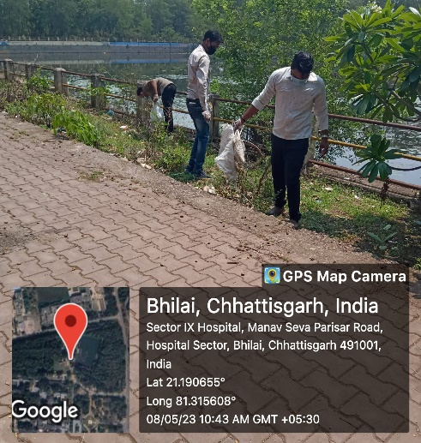
-lsDVj 9 ekuo lsok ifjlj fLFkr rkykc es aLoPNrk vfHk;ku
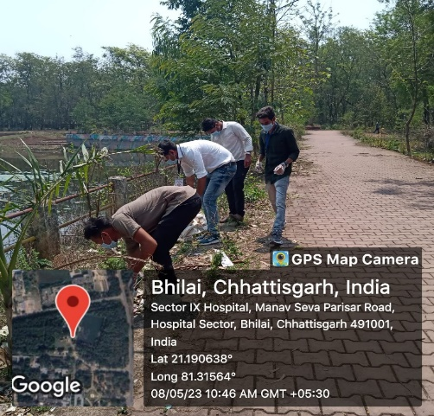

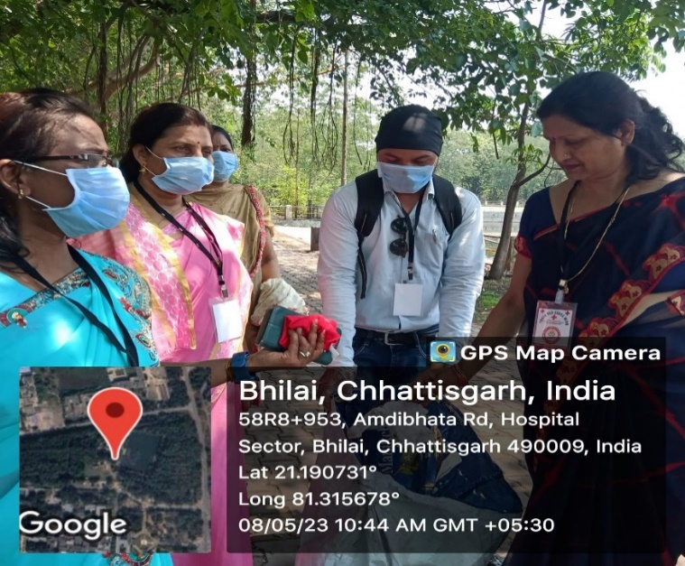
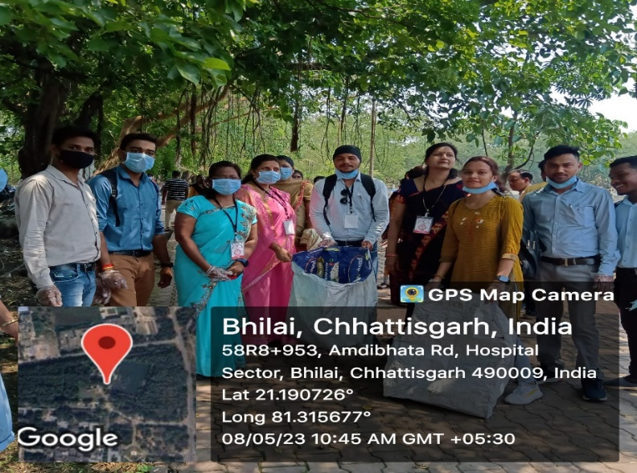

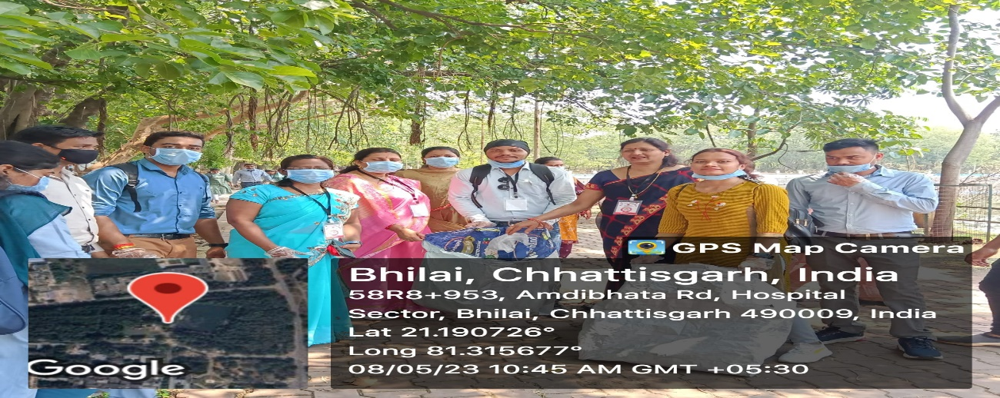

World Red Cross Day – 27-03-2023
- tMh&cwVh m|ku &nzks.k fxjh dk mn?kkV~~u
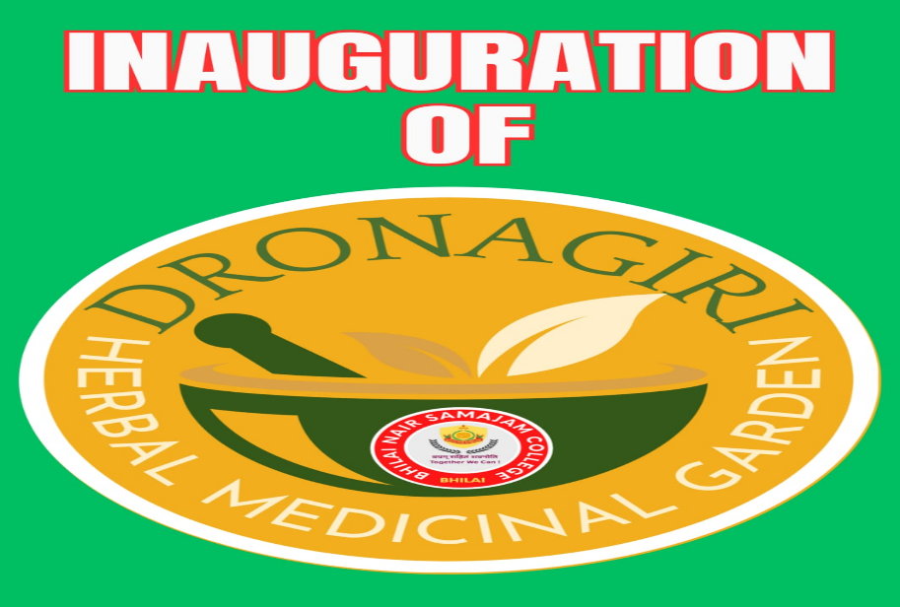

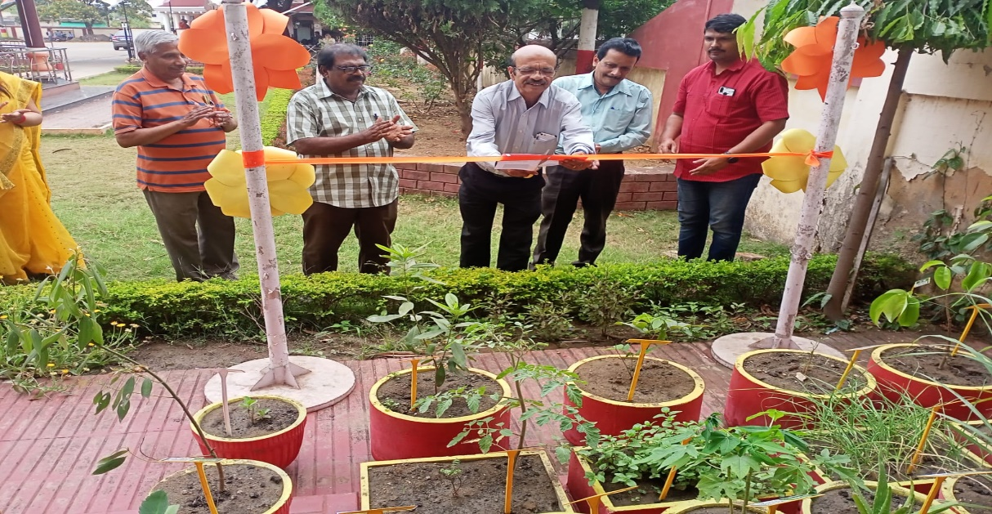

Nrhlx< ds eq+[;ea=h }kjk lEeku & easgnh Li/kkZ esa Hkkjr dk izfrfuf/kRo

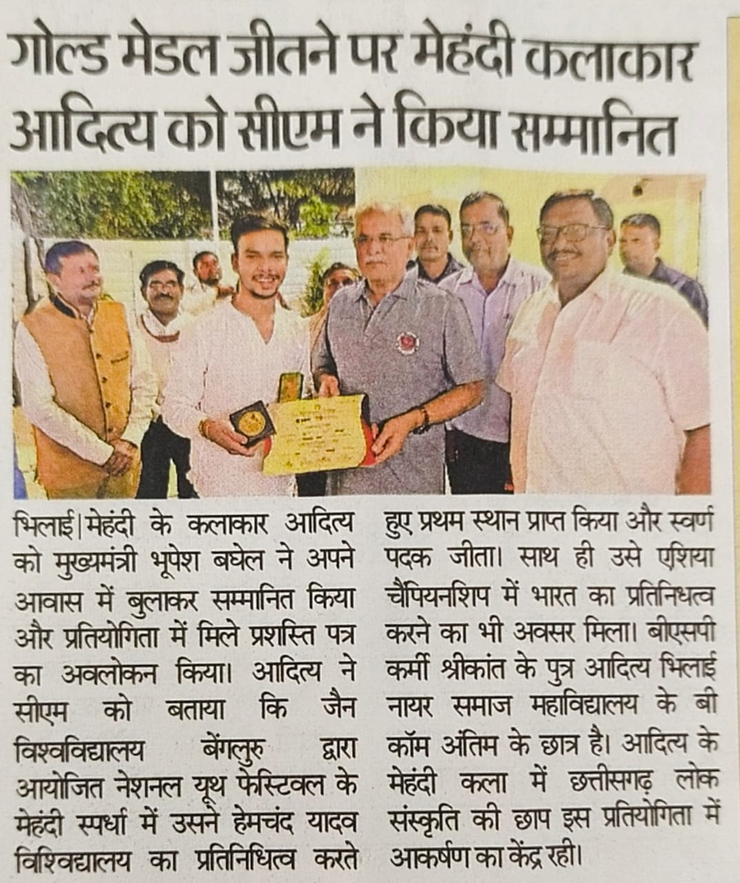
fo”o efgyk fnol & 08&03&2023
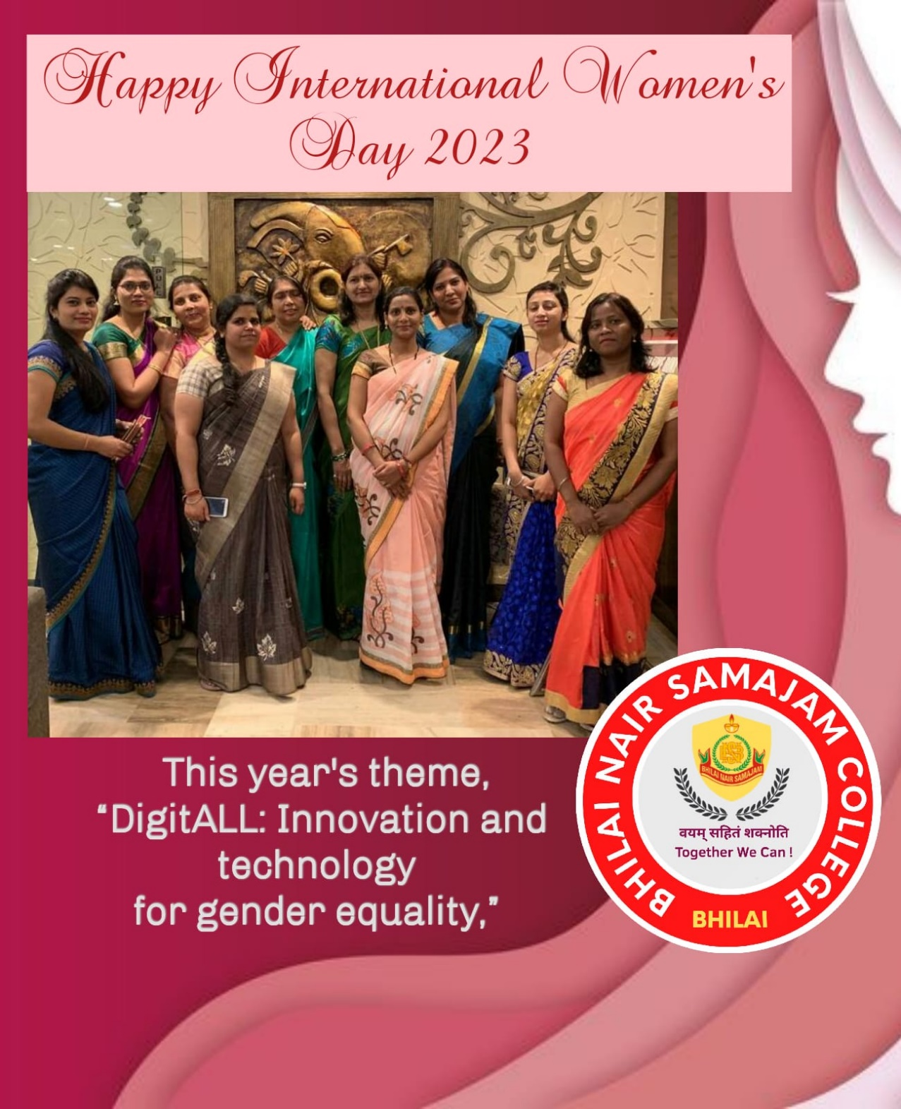

;wiksfj;k olarksRlo 2023
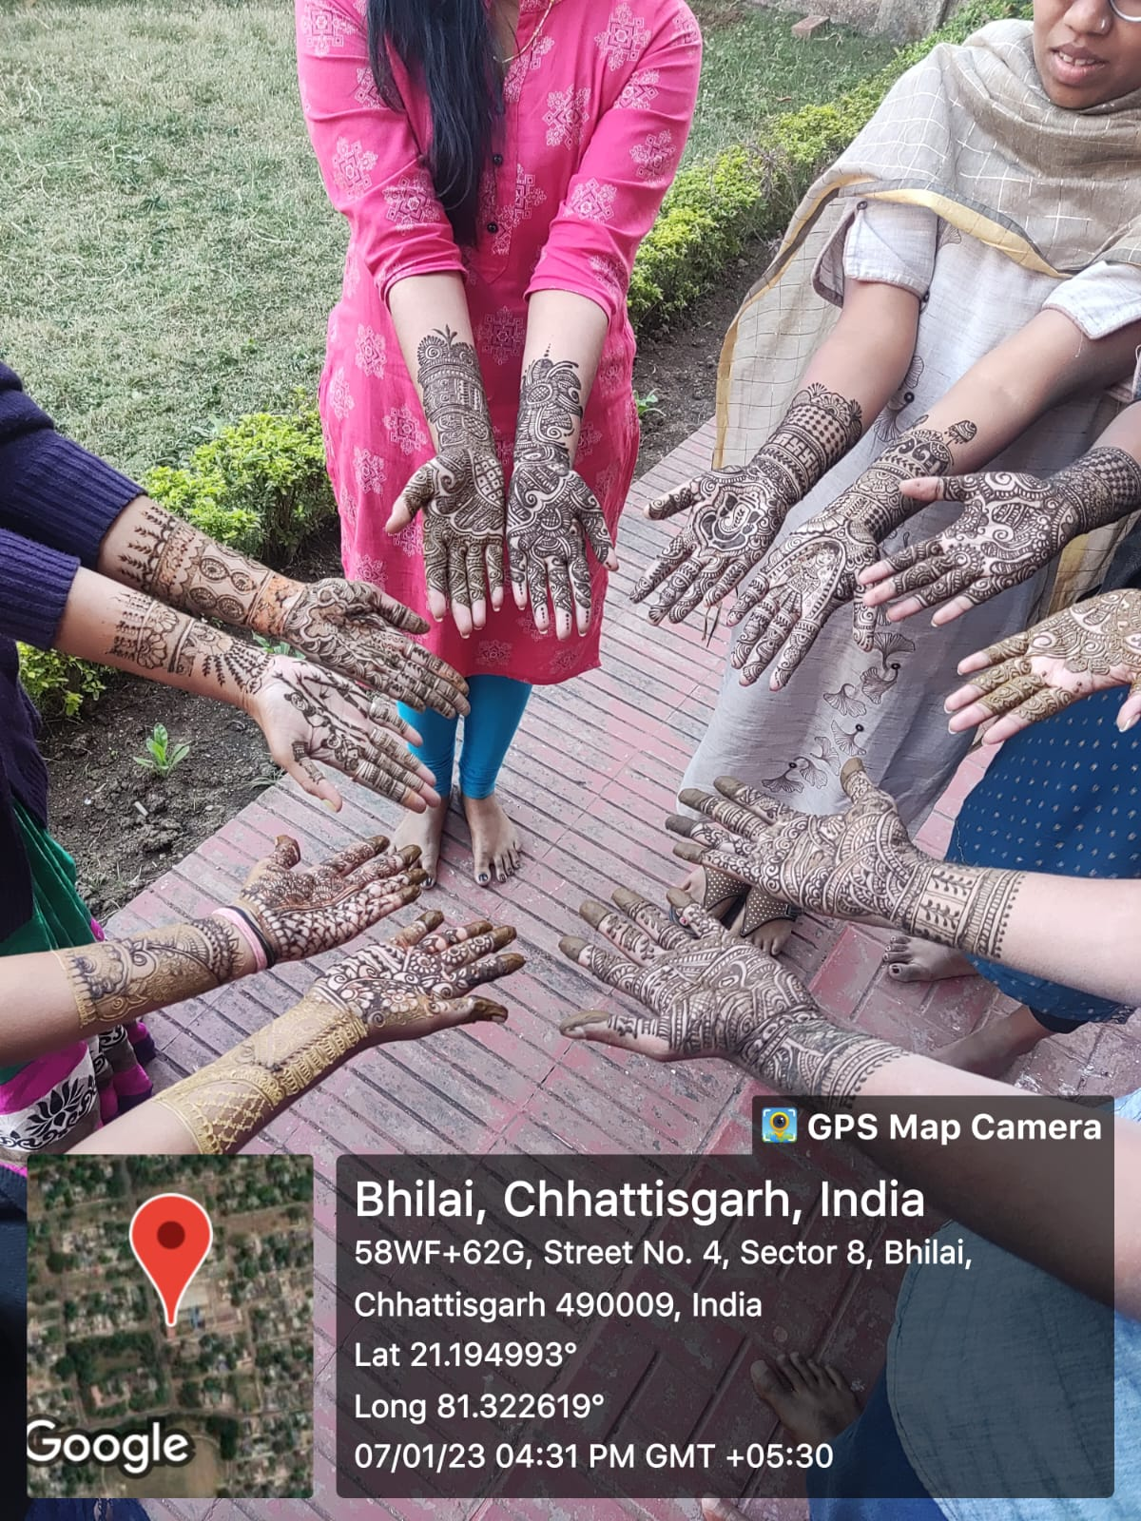
esagnh

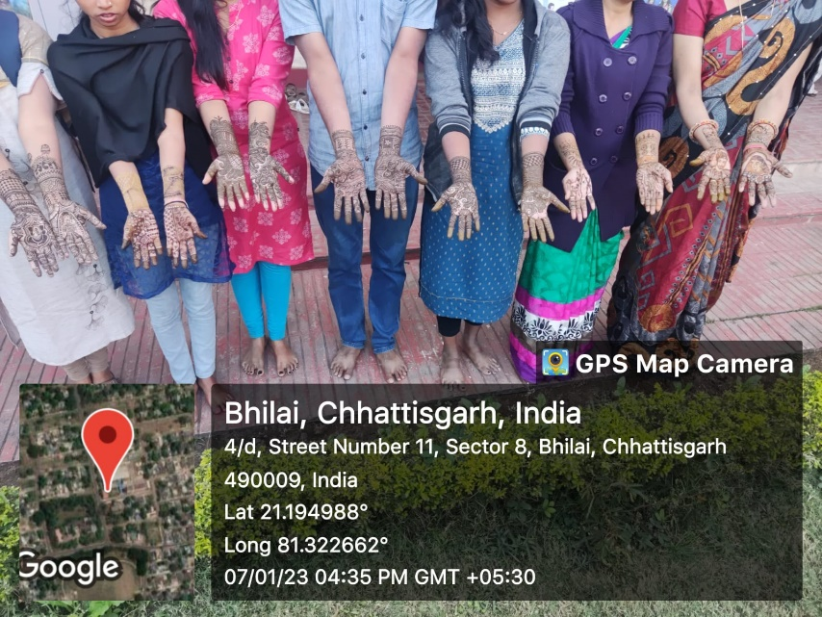
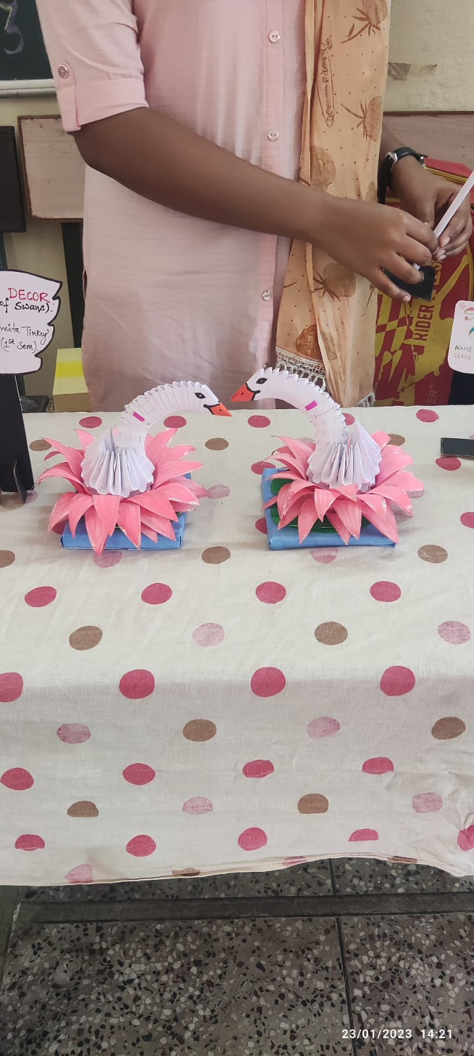
csLV vkmV vkQ osLV

lykn Msdksjs’ku
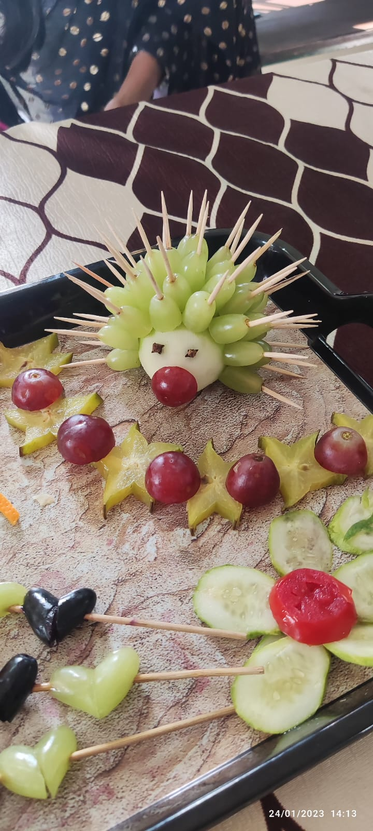

esganh izfr;ksfxrk

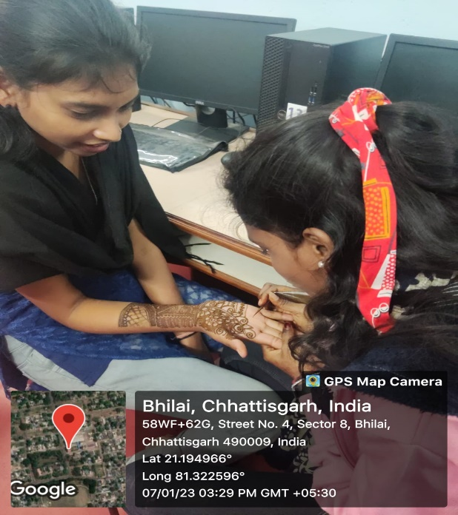
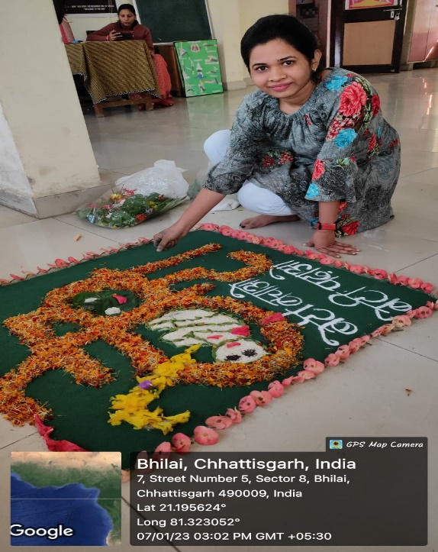

ljLorh iwtk ,oa x.kra= fnol 26&01& 2023

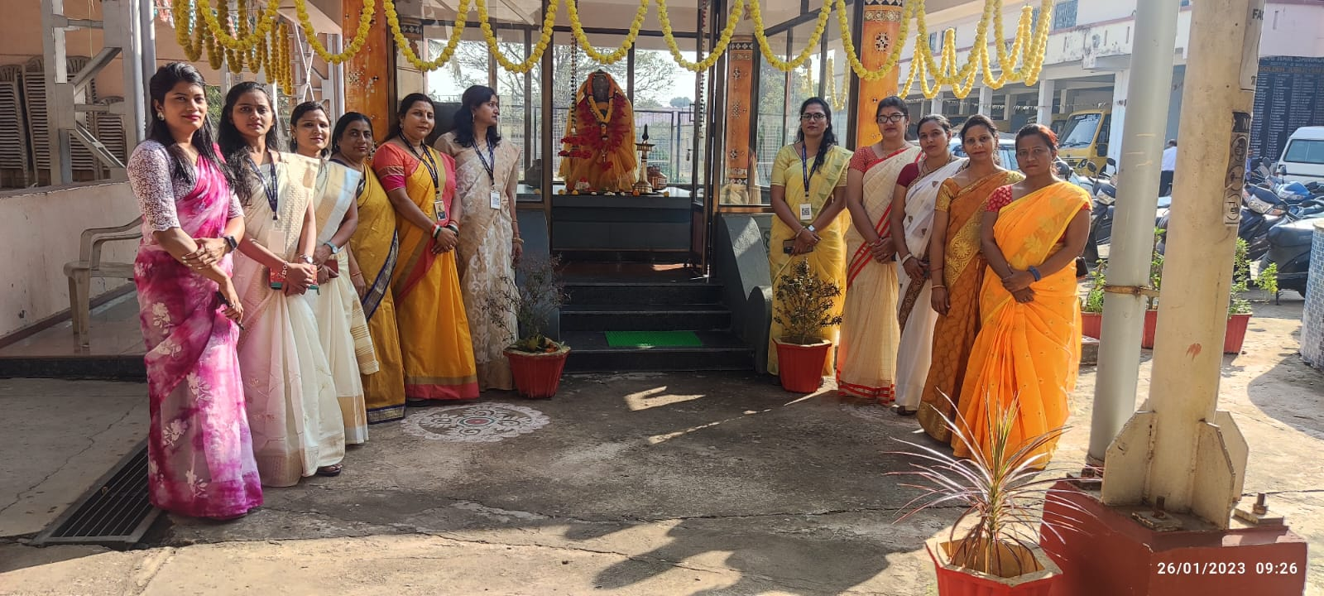

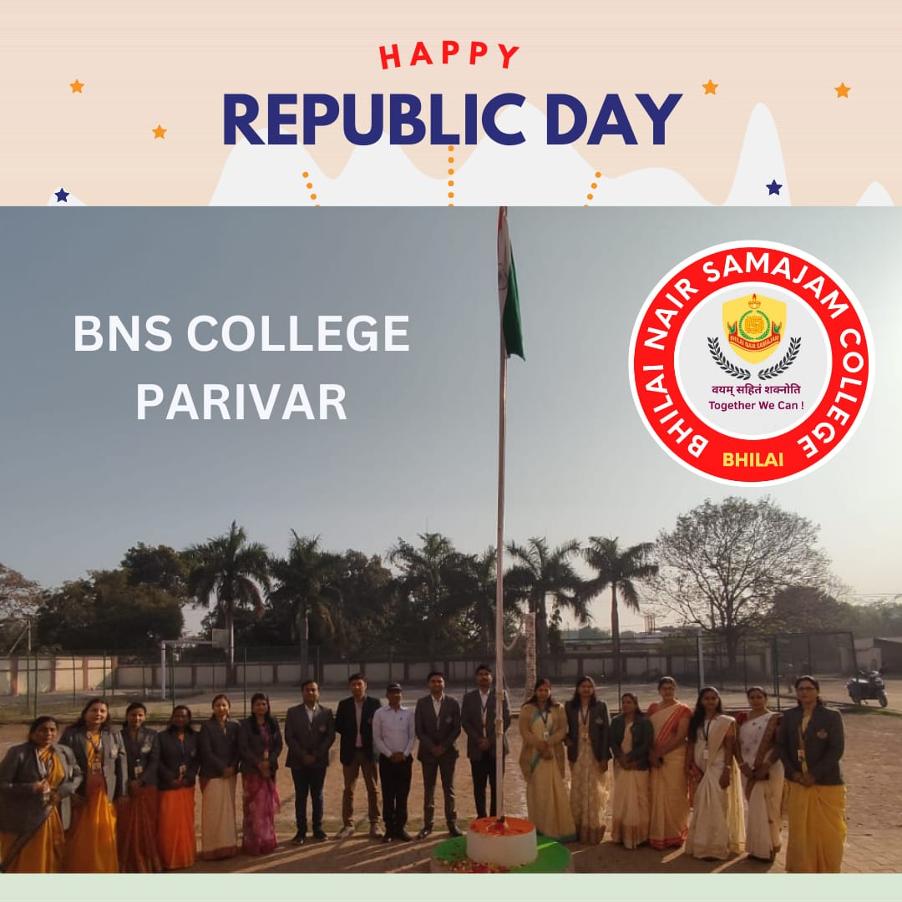

January 2024 ;qoksRlo 22&23 03&1&2023

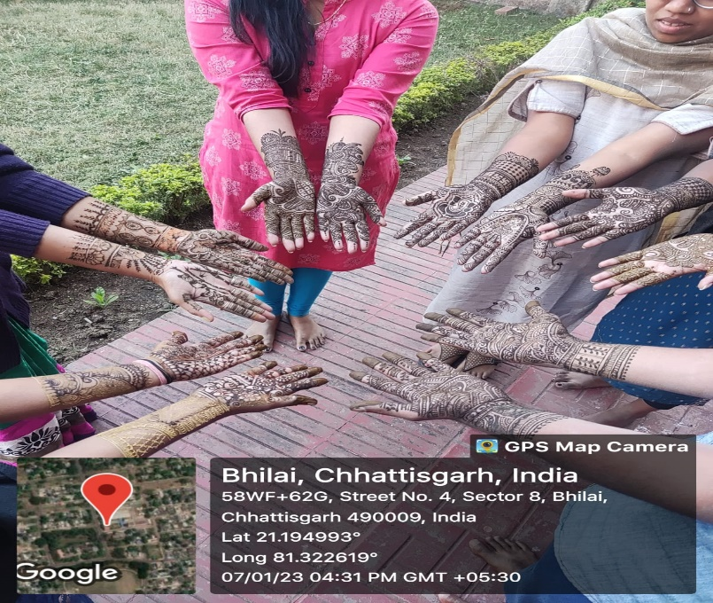
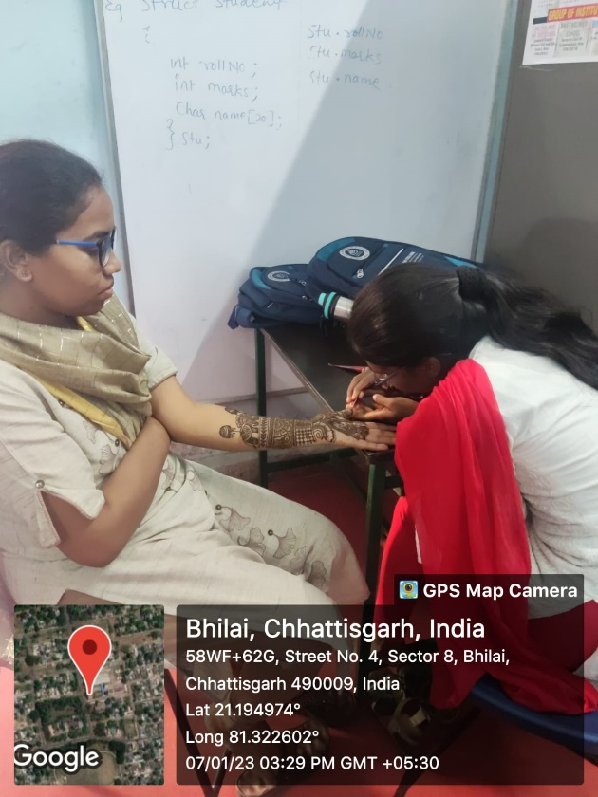

January 2023
01/01/2023 lnHkkouk jSyh

